Fraud-Resistant Meal Voucher Redemption and Real-Time Operational Analytics for Conference Management: Design and Evaluation of ConferenceCheck Mobile
Ndashi Bwalya Chisanga Student number 2021470105
Submitted in partial fulfilment of the requirements of the Final Year Project, Department of Computing and Informatics Supervisor: Mr. Mofya Phiri
October 2026
Repository: https://github.com/ndashi-chisanga6/ConferenceCheck-Mobile-Analytics-Meals-and-Notifications Validated state: tag final-resubmission

Declaration
I declare that this report is my own work. It has not been submitted, in whole or in part, for any other award at this or any other institution, and every source I have drawn on is acknowledged in the reference list.
The use of artificial intelligence tools during this project is disclosed in Appendix A, which records what each category of tool was used for, what was provided to it, and the limits placed on its use by Section 9 of the project proposal. All evaluation data in this study is seeded and synthetic: attendees, meal vouchers and sessions in the simulated-event exercise are generated by tools/seed-evaluation-event.php and describe no real conference or real person. No respondent or attendee data belonging to any third party was uploaded to any external tool at any point.
Signed: ...................................... Date: ......................

Conventions used in this report
Latencies are quoted in milliseconds to one decimal place in tables and rounded to the nearest whole millisecond in prose. Counts and rejection rates are exact throughout. Timings are wall-clock seconds or milliseconds for a single named run on PHP 8.5.8 with PostgreSQL 18, and the run is always named. Where a number also appears in docs/validation_report.md, the two are the same measurement and that file is the reproducible source; this report does not re-derive figures independently of it.

Table of Contents
Section | Title | Page
 | Declaration | 1
 | Conventions used in this report | 1
 | Abstract | 4
1 | Introduction | 5
1.1 | Problem statement | 6
1.2 | Aim | 6
1.3 | Objectives | 6
1.4 | Scope | 6
1.5 | Contributions | 7
2 | Literature Review | 7
3 | Methodology | 10
3.1 | System architecture and the component 4.3a / 4.3b boundary | 10
3.2 | Data model and integrity guarantees | 11
3.3 | The voucher redemption protocol | 11
3.4 | Session attendance and capacity alerting | 12
3.5 | Offline operation | 12
3.6 | Analytics, notifications and reporting | 12
3.7 | Tools and technologies | 13
3.8 | Ethical considerations and AI usage disclosure | 13
4 | Implementation | 13
4.1 | Code organisation | 13
4.2 | Defects found and fixed during review | 14
5 | Evaluation Methodology | 15
5.1 | Seeded evaluation dataset | 15
5.2 | Guarding against an artificially easy measurement | 15
5.3 | Metrics and acceptance criteria | 16
6 | Results | 16
6.1 | Automated correctness verification | 18
6.2 | Meal voucher redemption correctness | 19
6.3 | Session attendance and capacity correctness | 19
6.4 | Latency against the proposal's targets | 20
6.5 | Analytics dashboard freshness | 20
6.6 | Export correctness | 20
6.7 | Notification delivery | 21
6.8 | Baseline comparison, and its limits | 21
7 | Discussion | 22
8 | Limitations | 23
9 | Conclusion | 24
 | References | 25
A | Appendix A. Artificial intelligence usage disclosure | 27
A.1 | Purpose and scope | 27
A.2 | Before the supervisor's comments (to 30 September 2026) | 27
A.3 | After the supervisor's comments (7 to 10 October 2026) | 27
A.4 | Validation of AI-assisted output | 28
A.5 | Honest statement of disclosure limitations | 28
B | Appendix B. Defects found and fixed during the strict review | 28
C | Appendix C. Full evaluation figures | 29
D | Appendix D. Reproduction commands | 32
E | Appendix E. The running system, against each objective | 34
E.1 | What these figures do and do not show | 42
F | Appendix F. Reference verification record | 43

List of Tables
Table | Title | Section | Page
1 | Core relations and the integrity constraints underpinning system guarantees | 3.2 | 11
2 | Status of each acceptance criterion in the proposal's Table 3 | 6 | 16
3 | Adversarial and live checks, strict review | 6.1 | 18
4 | Concurrent redemption on PostgreSQL behind five server processes | 6.2 | 19
5 | Latency by endpoint against the proposal's targets | 6.4 | 20
6 | Export correctness, each CSV export against SQL run directly on the database | 6.6 | 20
7 | Status of each objective | 9 | 24
B1 | Defects found during review and their fixes | B | 28
C1 | Full evaluation output, tools/evaluation-results.json | C | 29
F1 | Verification of every reference, including the one withdrawn | F | 43

List of Figures
Figure | Title | Section | Page
1 | System architecture and the component 4.3a / 4.3b boundary | 3.1 | 10
2 | Organiser analytics dashboard | E | 34
3 | Trends and per-category redemption | E | 35
4 | Automatic capacity alerts on a device | E | 36
5 | Organiser broadcast delivered end to end | E | 37
6 | Attendee pass with a server-issued token | E | 38
7 | Meal categories and the per-device redemption trail | E | 39
8 | Scanner accepting a voucher | E | 40
9 | The same voucher refused on a second attempt | E | 41
10 | Report exports available to an organiser | E | 42

Abstract
On-site conference operations, meal service, session seating and attendee communication, are still widely managed with paper registers and printed vouchers, processes that scale poorly and are vulnerable to duplicate-collection fraud. This report presents the design, implementation and evaluation of ConferenceCheck Mobile: Analytics, Meals and Notifications, component 4.3b of a two-part conference management companion application whose sibling component, 4.3a, delivers attendee check-in capture and offline synchronisation separately. This project consumes check-in data through the REST API contract agreed with 4.3a, with a minimal check-in stub standing in for 4.3a during development, and contributes four capabilities that carry equal weight in its evaluation: a QR-code based meal voucher protocol in which single-use redemption is enforced in the database, by a row lock and a per-voucher uniqueness constraint on an append-only redemption relation, either of which alone prevents a second redemption; a near-real-time analytics dashboard refreshed every 30 seconds; session attendance tracking with configurable capacity thresholds and automatic overcrowding alerts; and dual-channel attendee notifications, combining Firebase Cloud Messaging push with an authenticated in-app feed carrying per-recipient delivery records. An offline scan queue, whose safe replay follows from the server's idempotent scan semantics and which keeps any scan the server has not definitively answered, extends the design to intermittent venue connectivity. The system was evaluated against a seeded 500-attendee event with three meal categories and a voucher per attendee per category, ten sessions and scripted concurrent-fraud scenarios, driven through the live API rather than through unit-level mocks. Not every criterion in the proposal's Table 3 was met, and Table 2 of this report gives the status of each. Duplicate redemption was refused in 100 of 100 sequential re-scans. In a concurrency experiment on PostgreSQL behind five server processes, every one of 50 five-way races produced exactly one redemption whenever the row lock or the unique constraint was in place, while a plain check-then-insert with both removed redeemed 48 of 50 vouchers more than once. All three categories were redeemable independently for each of twenty attendees. Median voucher-scan latency was 145.3 ms (95th percentile 261.0 ms), measured over loopback. Twenty check-ins injected at random moments appeared on the dashboard after a median of 18.1 s and at most 28.5 s. All four CSV exports matched direct SQL queries on row counts and totals. Capacity alerting was shown working but not timed, push delivery across a fleet of devices was not measured, and a live, human-staffed manual baseline was not run; these are stated as gaps rather than approximated with fabricated figures, and the qualitative argument for the baseline rests on the system's measured 145 ms scan-to-decision time and the fact that a paper voucher has no server-side check to fail. The results indicate that a row lock and a unique constraint each prevent double redemption under real parallel load, where a plain check-then-insert does not, while keeping scan-point latency well within interactive bounds.

1. Introduction
Modern conferences concentrate hundreds of attendees, multiple parallel sessions and time-boxed catering windows into a short operational period. The quality of the attendee experience depends on how efficiently organisers can verify entitlement, observe live operational state, and communicate changes as they happen. Traditional approaches rely on fragmented, largely manual tools: printed meal tickets, paper attendance registers and public-address announcements. These methods have three structural weaknesses. Paper vouchers are trivially duplicated or reused, and manual meal lines create congestion at service points. Organisers have no consolidated, real-time view of attendance or consumption, so operational decisions are made on stale or anecdotal information. Attendee communication is broadcast-only and unverifiable, with no record of who received a given update.
Quick Response (QR) codes provide a mature, standardised mechanism for machine-readable identification [1], and QR-based attendance has been proposed as a way to reclaim the lecture time that manual registers consume [3]. Cloud push-messaging services such as Firebase Cloud Messaging exist to send messages to mobile devices reliably [9], within the delivery guarantees Section 2 sets out, and modern cross-platform toolkits such as Flutter allow a single codebase to deliver the required scanning, charting and notification functionality [19]. This project applies these technologies to conference operations as component 4.3b of the ConferenceCheck capstone programme. A sibling component, 4.3a, handles the core attendee check-in capture and offline synchronisation engine separately; this project does not rebuild those features, and instead consumes check-in data through a shared REST API contract and focuses on what happens after check-in.

1.1 Problem statement
Conference organisers lack integrated, trustworthy tools for the operational tasks that follow attendee registration and check-in. Meal distribution based on printed vouchers or name lists cannot enforce single use; duplicate collection is difficult to detect at the point of service, and reconciliation after the event is manual and unreliable. Attendance and check-in data, even when captured digitally, is not surfaced to organisers in real time, so decisions about catering quantities, room allocation and staffing are made on guesswork. Session rooms have physical capacity limits, but organisers have no mechanism that tracks per-session attendance as it happens or warns them before rooms overcrowd. Communication with attendees is one-directional and unlogged, with no record of which attendees were reachable for a given schedule change. The consequence is operational inefficiency, measurable fraud exposure in catering budgets, safety risk from overcrowded rooms, and a degraded attendee experience.

1.2 Aim
To design, implement and evaluate the analytics, meal management, session capacity, notification and reporting component of the ConferenceCheck Mobile application, providing conference organisers with real-time operational insight, fraud-resistant meal voucher redemption and auditable attendee communication.

1.3 Objectives
- To design and implement a real-time analytics dashboard showing check-in progress, check-in rates and trends for event organisers. "Real-time" was delivered as near-real-time by design: the dashboard polls every 30 seconds (Section 3.6).
- To build a QR-code based meal voucher scanning and redemption system that enforces single-use redemption across multiple meal categories.
- To implement session attendance tracking with capacity management and overcrowding alerts.
- To build a push notification system for attendee communications and schedule updates, with per-recipient delivery records.
- To implement reporting and data export (CSV) functionality for event organisers.
- To evaluate redemption correctness, scan latency, dashboard freshness, notification delivery and export correctness against the Table 3 targets and a manual baseline.
- To produce comprehensive technical documentation and a publication-ready paper.

1.4 Scope
The project covers Flutter mobile modules for the analytics dashboard, meal voucher generation and scanning, session attendance and capacity alerts, a notification inbox and report access, together with the corresponding server-side business logic in a standalone Laravel API. It is built against the REST API contract agreed with component 4.3a's core check-in module, consuming check-in data as a read-only input to analytics, with a minimal check-in stub standing in for 4.3a so that this component can be built and tested on its own; check-in scanning, attendee search and the offline synchronisation engine are component 4.3a's remit and are out of scope here. Evaluation is performed on seeded, realistic event datasets including concurrent-scan fraud scenarios, described in full in Section 5. Payment processing, external ticketing integration and a full web-based administration panel are out of scope for both components.

1.5 Contributions
This work makes four contributions, each carrying equal weight in the evaluation that follows. The first is a redemption protocol in which the single-use guarantee is carried by the database's constraint machinery: a unique constraint on an append-only redemption relation, enforced inside a transaction with a row lock on the voucher, rather than by an application-level check, which eliminates time-of-check-to-time-of-use races by construction rather than by defensive coding. The second is a near-real-time analytics dashboard whose staleness bound is a stated design parameter (a 30-second poll) rather than an incidental property, chosen explicitly over introducing a WebSocket layer within the project's scope. The third is session capacity tracking whose overcrowding alerts are dispatched automatically on a threshold transition, converting a safety problem into an alert delivered before a room reaches capacity rather than a discovery made after. The fourth is a dual-channel notification design, push plus an authenticated in-app inbox with per-recipient delivery records, that treats Firebase Cloud Messaging's best-effort delivery model as a known property to be compensated for rather than assumed away, together with an offline scan queue whose replay safety is a direct corollary of the same idempotent server design that makes the redemption protocol safe.

2. Literature Review
The QR Code symbology is standardised in ISO/IEC 18004 [1], which specifies its data capacity and, critically for verification applications, its four selectable error-correction levels, allowing codes to remain machine-readable when partially damaged or poorly displayed on low-brightness screens. Tiwari [2] surveys the structural properties that drove QR adoption over one-dimensional barcodes in ticketing and access-control contexts: high capacity in a small print area, omnidirectional scanning, and decode robustness on commodity camera hardware. A key design implication, adopted in this project, is that the QR payload should be an opaque server-issued token rather than semantically meaningful data, so that possession of the printed code confers no information and validation authority remains entirely server-side.
Masalha and Hirzallah [3] propose a QR-based attendance system for a university setting, motivated by the observation that taking attendance manually consumes around ten minutes of each lecture, and they project that their design would remove most of that cost. Their paper describes the design and analyses it; it reports no experiment, and in particular no measured comparison against a manual register, so it should not be read as evidence of how much time or error such a system saves in practice. Its analysis does, however, identify the central weakness of naive QR attendance directly: a student outside the room can be sent an image of the displayed code by a student inside it, so any anti-fraud property must come from what the server does with a scan, not from the code itself. Their own answer to that is to bind the scan to a place and a person, through device location and a facial match. That weakness, rather than their proposed remedy for it, is what motivates the server-side single-use redemption design evaluated in this report, in which the database, not the scanning client, is the arbiter of whether a voucher has already been consumed.
That weakness has not gone away in the decade since, and the recent literature answers it by constraining the scan rather than the entitlement. Mohammed and Zidan [4] regenerate the code twice a second, so that a code which has been photographed is already stale by the time it is presented again; they report improved accuracy and a positive reception from students and instructors, drawn from surveys and record analysis rather than from a controlled comparison. Nwabuwe et al. [5], writing in the same journal as Masalha and Hirzallah nine years later, still describe a shared code as the central vulnerability, and bind the scan to a place and a device: the venue's polygonal coordinates are encoded in the code itself and checked by geofence, and the registering handset's IMEI is verified so that one person cannot register for another. Alsuhibany [6] secures the symbol instead of the scan, embedding a watermark so that a substituted or tampered code can be detected, and reports high accuracy over a dataset of 5,000 samples.
Each of these binds the act of scanning more tightly, to the moment, the place, the device or the integrity of the symbol, and each is a reasonable answer to the problem it takes on. None of them makes the thing being claimed single-use, which is a different guarantee and the one this project pursues. The distinction is in what is being recorded: an attendance mark may legitimately be registered once per person per session, and the fraud is someone registering who is not there, whereas a meal entitlement is consumed, and the fraud is the same person consuming it twice. Binding a scan to a place or a handset does not prevent the second of these, because the attendee is genuinely present and holding their own phone both times.
It is also worth recording what this body of work does not contain. None of [4], [5] or [6] reports a measured comparison against a manual process, and neither does [3]. Section 6.8 therefore has no external figure to set its own against, and says so rather than implying that one exists.
For the redemption transaction itself, Helland [16] provides the canonical treatment of idempotence in distributed systems: operations that may be retried, as scans on unreliable venue networks will be, must be designed so that repeated submission cannot produce repeated effect. In this project, that principle is realised by recording redemptions in an append-only table with a database-level uniqueness constraint on the voucher identifier, making double-redemption a constraint violation rather than an application-level race condition, and it is the same property that makes the offline scan queue described in Section 3.5 safe to replay without reconciliation logic.
Helland's argument concerns repeated submission; the harder case is simultaneous submission. Berenson et al. [20] name the underlying anomaly the lost update: one transaction reads a data item, another updates it, and the first then writes on the basis of what it read. A redemption that checks a voucher's status and then marks it redeemed has exactly this shape, and an application-level status check cannot close it, because two transactions can both read the unredeemed status before either writes. Two database mechanisms can. A row lock taken with SELECT ... FOR UPDATE makes any other transaction that tries to lock or update the same row wait until the first transaction ends [21], so the second reader sees the committed redemption. A unique index makes a second insert of the same key wait for the first inserting transaction, and fail if that transaction commits [22]. Section 6.2 tests each mechanism on its own, and the two together, against the case they are meant to prevent.
On the presentation side, Few [7] establishes design principles for operational dashboards: a dashboard must fit on a single screen, prioritise the small number of measures that drive action, and use visual encoding rather than tables of numbers for trend perception. Nielsen [8] provides the response-time thresholds that inform this project's latency targets: feedback within one second preserves a user's flow of thought, which sets the budget for scan-validation round trips at a catering service point where queue throughput matters, and is the threshold against which Section 6.4 reports the measured results.
For attendee communication, Firebase Cloud Messaging documentation describes an architecture in which each app instance registers for messages and is identified by its own registration token [10], and states that a message accepted by FCM has not thereby been delivered: a message for an offline device is stored and delivered when the device reconnects, and delivery may be delayed or may not happen at all [11]. Delivery is therefore best-effort rather than guaranteed, tokens expire, and devices without Google Play services are unreachable, all of which motivate the dual-channel design evaluated in Section 6.7, in which every notification is also persisted to an in-app inbox with per-recipient delivery records. The service interface between the mobile client and backend follows the REST architectural style [12]; endpoint authentication uses bearer tokens as specified in RFC 6750 [13] and implemented by Laravel Sanctum [14], with mobile-specific hardening guided by the OWASP Mobile Application Security Verification Standard [15]. The client architecture applies the separation of presentation, state and data access descended from the Model-View- Controller pattern [17], realised in Flutter's widget and provider model [19].
Taken together, this body of work indicates that the individual technologies are mature, but that existing systems apply them piecemeal: attendance tools do not manage catering, catering tools do not track session capacity, and none provide the organiser with a consolidated live operational view. This project's contribution, set out in Section 1.5, is that integration, with each design decision traceable to a specific finding in this literature rather than to convention.

3. Methodology

3.1 System architecture and the component 4.3a / 4.3b boundary
The system is a client-server architecture with three tiers: a Flutter mobile application, a standalone Laravel backend exposing a REST API [12], and a PostgreSQL database, with Firebase Cloud Messaging as the external push channel.
Figure 1. System architecture and the component 4.3a / 4.3b boundary.
ConferenceCheck Mobile: Flutter application (Android)
Component 4.3a: Core Check-in and Sync Engine (sibling, developed separately, out of scope): attendee check-in capture; offline synchronisation engine | Component 4.3b: Analytics, Meals and Notifications (this project): analytics dashboard; meal voucher scan and redemption; session capacity and overcrowding alerts; notification inbox; reports and CSV export
REST API contract agreed with 4.3a, Sanctum bearer-token authenticated. 4.3b consumes check-in data from seeded fixtures and a minimal check-in stub during independent development
Standalone Laravel REST API implementing the agreed contract, with a minimal check-in stub + PostgreSQL database
Push dispatch: Laravel → Firebase Cloud Messaging (external) then to the device, for component 4.3b notifications only
The mobile application follows a layered structure derived from the Model-View-Controller separation [17]: a presentation layer of Flutter widgets, a state layer of Riverpod providers holding screen state and orchestrating asynchronous calls, and a data layer of repository classes wrapping a single authenticated REST client. Platform services, camera access via mobile_scanner and push token registration via firebase_messaging, are isolated behind interfaces so that they can be stubbed in widget tests. The backend is a standalone Laravel 13 application, started from the Laravel starter kit, that implements the API contract agreed with component 4.3a, with a minimal check-in stub so that this component can be built and tested on its own. Every endpoint requires a Sanctum-issued bearer token [13, 14] and returns a uniform JSON envelope with success, message and data fields. Authorisation is role-based and scoped to the event: organisers manage the event, view analytics and download reports; scanners submit scans and read the attendee list, vouchers and redemption history the scanner app needs; attendees read only their own vouchers and the notifications sent to them. The first submitted version did not enforce the attendee restrictions on four routes; Section 6.1 describes the defects and the tests that now cover them.

3.2 Data model and integrity guarantees
The system's anti-fraud properties are carried by relations and constraints rather than by application code.
Table 1. Core relations and the integrity constraints underpinning system guarantees.
Relation | Purpose | Key integrity constraint
attendees | Event attendee records, shared with 4.3a | Unique ticket_code; unique qr_token
meal_categories | Meal windows, for example Breakfast, Lunch, VIP Lunch | Owned by event; time-windowed
meal_vouchers | One voucher per attendee per category | Unique qr_token; unique (attendee, category) pair
meal_redemptions | Append-only record of each redemption; the model refuses updates and deletes | Unique meal_voucher_id enforces single use; foreign keys restrict rather than cascade deletes
event_sessions / session_attendance | Conference sessions and per-session attendance | Unique (session, attendee) prevents duplicate attendance
device_tokens / notification_recipients | FCM registration and per-recipient delivery records | Delivery auditable per user and per notification

3.3 The voucher redemption protocol
Voucher issuance generates exactly one voucher per attendee per meal category, each carrying a cryptographically random, globally unique QR token that is opaque: it encodes no attendee or entitlement information, so possession of a screenshot confers nothing beyond what the server chooses to honour [2, 3]. The protocol has four steps. A scanner device decodes the QR token and submits it with its own device identifier to the scan endpoint. The server resolves the token to a voucher, verifying that it belongs to the event being served and that the category's service window is open. Within a database transaction, the server locks the voucher row (lockForUpdate()), so a second scan of the same voucher waits until the first transaction ends. It then checks that the voucher is still unused; a scan that finds it already redeemed receives a definitive "already redeemed" response naming the earlier redemption time [16]. Only then does it mark the voucher redeemed and insert the redemption record. The unique constraint on the record's voucher identifier is a second, independent guarantee: if the lock were ever missing, the second insert would fail, and that failure is caught and returned as the same "already redeemed" response rather than as a server error. The redemption record, including the redeeming device identifier and timestamp, cannot be changed afterwards: the model refuses updates and deletes, and the foreign keys restrict, rather than cascade, the deletion of the event, attendee, category, voucher or user it refers to, so it remains a complete audit trail for post-event reconciliation. Section 6.2 measures the protocol under real parallel load, including with each of the two guarantees removed.

3.4 Session attendance and capacity alerting
Each session carries a room capacity. Attendee entry is recorded by scanning the attendee's QR badge at the session door; the unique (session, attendee) constraint prevents double counting. The backend evaluates occupancy against capacity on every scan, under a lock on the session row that serialises scans of one session, and exposes threshold states: available, warning at or above a configurable fraction of capacity (default 90%), and over_capacity. A threshold transition dispatches an organiser-targeted push notification after the attendance transaction commits, so a push is never sent for attendance that ends up rolled back, converting room overcrowding from a discovery made after the fact into an alert intended to arrive before the room reaches capacity; Section 6.3 states how far that was shown.

3.5 Offline operation
Scans captured without connectivity are persisted to a durable FIFO queue on the device and replayed in order when the network returns. Replay safety is a direct corollary of the server's idempotent scan semantics described in Section 3.3: an entry that already reached the server resolves to a definitive duplicate answer rather than a second effect, so the queue can be drained without reconciliation logic. A definitive business answer settles an entry: success, already redeemed or duplicate (409), invalid token (404), or not redeemable now (422). Anything else, including no connection, an expired login, rate limiting or a server fault, keeps that entry and every entry after it for the next attempt, and an entry queued while a replay is running is kept. The replay tests are listed in Section 6.1.

3.6 Analytics, notifications and reporting
The analytics dashboard consumes four aggregate endpoints, namely summary, check-ins over time, meal redemptions by category, and session attendance, computed directly from the operational tables, including check-in data produced by component 4.3a. Following Few's single-screen principle [7], the landing view presents total registrations, check-in count and rate, and voucher redemption progress as headline figures, with time-series charts beneath. The client self-refreshes on a 30-second polling interval, a deliberate trade-off documented in Section 8: polling over the existing REST API avoids introducing a WebSocket layer while keeping data staleness within one operational decision cycle. Section 6.5 measures the resulting freshness by injecting check-ins and timing their appearance.
Organisers compose notifications targeted at all attendees or at role-scoped groups. The dispatch service resolves the target set into per-recipient delivery records, then delivers via Firebase Cloud Messaging to every registered device token [10]. Because FCM delivery is best-effort [11], every notification is simultaneously persisted and served through an authenticated in-app inbox, so an attendee whose device was offline, or lacks Google Play services, still receives the message on next application open; the inbox shows each user only the notifications they were a recipient of, and the per-recipient records make delivery auditable. Firebase demo mode, used to try the app without credentials, records a send as demo on the notification and every recipient, never as sent, so it cannot be mistaken for delivery.
The reporting module exposes CSV exports of attendance, per-category meal redemptions, per-session attendance and notifications to organisers. Each export is written while its rows are read from the database in chunks of 1,000, so the whole export is never held in memory. Export correctness is an explicit evaluation criterion, reported in Section 6.6.

3.7 Tools and technologies
Mobile: Flutter 3.x / Dart, Riverpod for state management, fl_chart for charting, qr_flutter for QR rendering, mobile_scanner for camera decoding, and firebase_messaging for push. Backend: Laravel 13 (PHP), started from the Laravel starter kit, Laravel Sanctum for token authentication, and PHPUnit for API tests. Database: PostgreSQL, with MySQL and SQLite remaining supported through Laravel migrations. Infrastructure: Firebase Cloud Messaging, Git for version control.

3.8 Ethical considerations and AI usage disclosure
The system processes personal data such as names, contact details and attendance behaviour, and therefore observes the data-minimisation and consent requirements of the Data Protection Act No. 3 of 2021 of Zambia [18]. Attendee records hold only fields required for event operations, QR tokens are opaque and carry no personal data, API access is authenticated and role-scoped following OWASP MASVS guidance [15], and evaluation is performed exclusively on synthetically seeded data, so no real attendee data was processed during development or evaluation. Client-server traffic must be encrypted in any deployment; the development build talks to a local server over plain HTTP (Section 8). The system should not be demonstrated with real attendee data until the deployment hardening listed in Section 8 is done. The use of artificial intelligence tools is disclosed in Appendix A, against the scope limits set out in Section 9 of the project proposal (v3, resubmitted on 23 September 2026 and under review).

4. Implementation

4.1 Code organisation
What in this repository is this component's work. The repository is a standalone Laravel 13 application, started from the Laravel starter kit, so it also carries the starter kit's own pages, settings and authentication code and their 39 tests, none of which is this component's work. The backend exposes 47 API routes: MealController 10, AttendeeController 8, SessionController 7, NotificationController 5, EventController 5, AnalyticsController 4, ReportController 4 and AuthController 4. Two of those, the check-in scan and check-in endpoints on AttendeeController, are a minimal stub for component 4.3a's check-in capture, written here so this component can be built and tested on its own; this component only reads check-in data, for analytics, and integration with 4.3a's own API was not demonstrated. AuthController and EventController are the authentication and event scaffolding both components need. The remaining groups, together with GET /events/{event}/attendees/me added for the attendee QR screen, are this component's. The mobile application is this component's alone, and its feature modules bear the boundary out directly: mobile/lib/features/ holds dashboard, meals, sessions, notifications, reports, attendee, events, auth, profile and sync, with no check-in capture module anywhere in it.
How the history and tags should be read. The git history before 10 July 2026 was reconstructed from the working prototype in one session (9 and 10 July, with follow-on commits to 14 July), grouping the development done before then into module-by-module commits; docs/milestone_tracker.md and docs/STRICT-REVIEW.md record this. The milestone tags were created in September and mark the commit that best represents each phase's deliverable, not the dates in the proposal's Table 4, so they do not by themselves show when the work happened. The work done after the supervisor's comments on the first submission is listed with its commit dates in docs/remaining_work.md.
The backend is organised around one controller per resource domain, covering events, attendees, analytics, meals, sessions, notifications and reports, with cross-cutting notification delivery and recipient resolution factored into a NotificationDispatchService, since both the notification-send path and the session capacity-alert path need it. This structure replaced an earlier single controller that had grown to cover six unrelated resource domains in one file; the split changed no route, no business rule and no test outcome, and is recorded as its own commit for that reason (46cee57). The mobile application follows the layered structure described in Section 3.1. Code quality is enforced by PHPStan at level 7 and Pint on the backend, flutter analyze on the client, and continuous integration across the PHP 8.4 and 8.5 matrix; all are clean at the time of writing.

4.2 Defects found and fixed during review
A strict, evidence-based review of the system against the portal objectives and the proposal was carried out by the student partway through development, with assistance from Claude (Appendix A), using the full backend test suite, live adversarial API calls, flutter analyze and flutter test, and code inspection of every claimed safeguard (docs/STRICT-REVIEW.md). Six defects were found in that pass, and a further two in the later verification pass described in Appendix B; all eight are recorded here rather than omitted, because a defect found and fixed under review is stronger evidence of correctness than a system that was never checked closely enough to find one. Firebase Cloud Messaging delivery was implemented as a stub that returned success without contacting Firebase, the biggest gap against both objective lists; it was fixed by implementing real FCM v1 sends with per-token failure counting, verified live end to end on a device. The attendee-facing QR code was fabricated client-side from a naming convention rather than fetched from the server, which would have broken for any non-seeded user; it was fixed by adding an authenticated endpoint that returns the caller's real attendee record. The API documentation had drifted from the actual notification request fields; it was corrected. Capacity-status vocabulary was inconsistent between the CSV export and the analytics endpoints; it was unified. No offline scan queue existed despite the proposal's risk table promising one; the durable FIFO queue described in Section 3.5 was built to close that gap. Mobile test coverage was thin, at four tests across roughly fifteen screens; it was broadened to nineteen tests covering the offline queue's persistence, ordering and replacement semantics, core widgets, formatters and model parsing, and later to twenty-seven with the replay tests described in Section 6.1. That review did not find the authorisation and replay defects the supervisor later identified; those, and their fixes, are in Section 6.1. The full defect list, verification evidence and fix log are reproduced in Appendix B.

5. Evaluation Methodology
Evaluation proceeds at two levels: correctness of individual business rules, verified continuously through automated tests and, once, through an adversarial manual pass; and end-to-end operational performance, verified in a structured simulated-event exercise on seeded data with scripted fraud scenarios.

5.1 Seeded evaluation dataset
The evaluation dataset is generated by tools/seed-evaluation-event.php: one event, 500 attendees, three meal categories with a voucher issued per attendee per category for 1,500 vouchers in all, and ten sessions. Three categories rather than one because the single-use guarantee is held per (attendee, category): with one category nothing would distinguish it from a per-attendee guarantee, and the second project objective is redemption across several. The proposal specified four categories for the simulated event; three were used, which is enough to test that redeeming one category leaves the others redeemable, and the proposal's targets are kept unchanged. The dataset is driven through the live HTTP API, against a running backend, rather than through unit-level mocks or direct database manipulation, so that the measured latencies include routing, middleware, authentication and serialisation overhead exactly as a real scanner client would experience them. Three scripts do this: tools/run-evaluation.py for correctness, latency and export correctness, tools/run-concurrency-experiment.py for redemption under parallel load, and tools/measure-dashboard-freshness.py for dashboard freshness.

5.2 Guarding against an artificially easy measurement
Three design choices keep this evaluation from measuring only what the system was built to pass.
First, the concurrency claim is tested by an experiment that can fail. A race test run on a server that executes one request at a time cannot tell a locked, constrained redemption apart from a plain check-then-insert, because the requests never overlap: every losing scan is refused by the ordinary status check. The first version of this evaluation had exactly that weakness. The concurrency experiment therefore runs five separate PHP server processes against PostgreSQL, sends each race's five scans to a different process at the same instant, and repeats the races with the row lock removed, with the unique constraint removed, and with both removed, each configuration served from a scratch copy of the same commit. The configuration with both removed is the negative control: if it also produced one redemption per race, the test would show nothing. A second run injects a 50 ms pause between the check and the write in every configuration, so the result does not depend on how often the natural timing happens to overlap.
Second, freshness is measured by injecting check-ins and timing their appearance through a poller that reproduces the app's refresh cycle, rather than derived from the poll interval.
Third, export correctness is checked against SQL run directly on the database, not against another API endpoint that could share a fault with the export, and on a total per export as well as on the row count.
The adversarial pass recorded in docs/STRICT-REVIEW.md and reproduced in Appendix B was conducted separately from, and before, the quantitative round in Section 6, using live API calls with invalid QR tokens, wrong roles and missing authentication. It did not find the authorisation defects described in Section 6.1, which were found by the supervisor after submission.

5.3 Metrics and acceptance criteria
Success criteria were set in the proposal's Table 3: 100% of duplicate scans rejected including concurrent submissions; median scan latency under 500 ms with a 95th percentile under 1 second; dashboard data no more than 30 seconds behind database state; a capacity warning delivered before a session reaches 100% occupancy; 95% or more of online devices receiving a push within 30 seconds, with 100% of recipients reachable via the in-app inbox on next open; and CSV export row counts and totals equal to database ground truth exactly; and a comparison with a manual baseline. Each criterion is given a status in Table 2 and addressed by name in Section 6.

6. Results
Table 2. Status of each acceptance criterion in the proposal's Table 3. Sources: tools/evaluation-results.json, tools/concurrency-results.json, tools/freshness-results.json.
Criterion (proposal Table 3) | Target | Result | Status
Duplicate redemption rejection, including concurrent submissions | 100% | 100/100 sequential re-scans refused; on PostgreSQL behind five server processes, 50/50 five-way races with exactly one redemption with the lock, the constraint or both in place; with both removed, 48/50 vouchers redeemed more than once (Section 6.2) | Met
Scan validation latency | median < 500 ms, p95 < 1 s | voucher scan 145.3 ms / 261.0 ms (n=200); session scan 128.4 ms / 228.7 ms (n=40) | Met on loopback only (Section 8)
Dashboard freshness | ≤ 30 s behind the database | 20 injected check-ins: median 18.1 s, p95 28.4 s, max 28.5 s, 20/20 within 30 s | Met in the measured run; by design the worst case is one 30 s cycle plus a fetch, fractionally over 30 s (Section 6.5)
Capacity warning before 100% occupancy | warning delivered before full | two automated transition tests; one observation on an emulator | Partly met: shown, not timed
Push delivery | ≥ 95% of online devices within 30 s | one device, one observed delivery of about 5 s | Not measured
In-app inbox reach | 100% of recipients on next open | a recipient record for every recipient, inbox reads filtered to recipients and tested; not measured on devices | Partly met
Export correctness | row counts and totals equal to the database | all four exports equal to direct SQL on row counts and on a total each (Section 6.6) | Met
Comparison with a manual baseline | measured against a staffed paper line | not run (Section 6.8) | Not run
Two further results are not Table 3 criteria but test the guarantees the design rests on: all three categories were redeemable independently for 20 of 20 attendees, and 20 of 20 sequential duplicate session scans were refused. Four criteria are met, one of them on loopback only; two are partly met; push delivery across a fleet was not measured; and the manual baseline was not run.

6.1 Automated correctness verification
The backend test suite passes in full: 70 tests, 288 assertions, on PHP 8.5.8 with PostgreSQL 18.2. Of those, 31 tests (152 assertions) in tests/Feature/ConferenceApiTest.php exercise this component; the other 39 are the Laravel starter kit's example, dashboard, authentication and settings tests, which came with the application scaffold. The 31 are named in Section 0.1 of the validation report. PHPStan at level 7 and Pint are both clean. The Flutter client is analyzer-clean with 27 of 27 tests passing.
Access control. After submission the supervisor found that an authenticated attendee assigned to the event could read another attendee's voucher token, the attendance export, the event's redemption history and a notification addressed to organisers, on a local database with synthetic data. These were defects in the authorisation rules, contradicting what Section 3.1 then claimed. They are fixed: an attendee can open only their own voucher, reports are organiser only, the redemption history, attendee list, voucher list and session attendance are staff only, and notifications are listed and opened only by their recipients. Four further defects of the same kind were fixed with them: registration let a caller choose the organiser role, any organiser could delete any user's device token, the custom notification target was sent to every attendee, and linking an attendee record to a scanner demoted them. Each fix has a test that expects 403 and that fails against the earlier code (validation report, Section 7).
Offline replay. Two defects in the replay path were fixed: every HTTP error, including an expired login or a server fault, was treated as settled and the scan dropped; and a scan queued while a replay was running could be overwritten. Eight tests now drive the replay itself with a fake API, covering an authentication failure, a server fault, a scan queued during a replay, a queue left by an earlier app run, and a scan kept after a 401 surviving a restart (validation report, Section 8). Camera decoding of QR codes was checked by hand and not measured; the only QR test covers the trimming of a manually entered token.
Beyond the automated suite, the adversarial checks from the strict review confirmed behaviour under conditions the unit tests did not then exercise.
Table 3. Adversarial and live checks, strict review (docs/STRICT-REVIEW.md).
Verification | Result
Live API exercise, all endpoint groups | all responded correctly, including 401/403 enforcement for the checks made
Double meal-voucher scan | rejected
Duplicate check-in / session scan | flagged duplicate: true / rejected
Over-capacity session scan | recorded with over_capacity, warning, and an automatic organiser alert
Notification send to all_attendees | recipient records created, per-recipient delivery status recorded
Four CSV report downloads | all well-formed

6.2 Meal voucher redemption correctness
Sequentially, 100 of 100 re-scans of an already-redeemed voucher were refused.
The evaluation script's own race step, 20 races of five simultaneous scans of one token, resolved to exactly one success each, but it ran on a development server that executes one request at a time, so it cannot distinguish the design from a plain check-then-insert and is not the evidence for the concurrency claim (Section 5.2). The evidence is the concurrency experiment, in which five separate server processes received each race's five scans at the same instant, 50 races per configuration (Table 4).
Table 4. Concurrent redemption on PostgreSQL behind five server processes, 50 races of five simultaneous scans per configuration. Source: tools/concurrency-results.json.
Row lock | Unique constraint | Races with one success | Vouchers redeemed more than once | With a 50 ms window: one success / redeemed more than once
on | on (as built) | 50/50 | 0 | 50/50 / 0
off | on | 50/50 | 0 | 50/50 / 0
on | off | 50/50 | 0 | 50/50 / 0
off | off | 2/50 | 48 | 0/50 / 50
With both safeguards removed, 48 of 50 vouchers were redeemed more than once even without the injected pause, so the race is real under this load and the experiment can detect it. With either safeguard in place, every race produced exactly one redemption and no response was a server error. Each safeguard is therefore sufficient on its own, and the system as built carries both: with the lock in place, losing scans wait for the winner and are then refused by the status check; the unique constraint refuses the second insert if the lock is missing.
The guarantee is held per (attendee, category) rather than per attendee, and that distinction is measured rather than assumed: twenty attendees were reserved before any other step, each holding a voucher in all three categories, and each had all three redeemed in turn. All sixty redemptions were accepted and every repeat of the first was refused, so redeeming one category neither consumes nor blocks another. Ground truth is exact: 280 redemption rows exist for 200 successful batch scans, 20 race winners and 60 cross-category redemptions, equal to a direct SQL count.

6.3 Session attendance and capacity correctness
The unique (session, attendee) constraint held under the same sequential treatment: 20 of 20 duplicate session check-ins were refused. Session scans now lock the session row, and a scan that reaches the unique constraint returns 409 rather than a server error; that path is tested by inserting a competing row between the check and the insert, but the session path was not part of the parallel experiment, so it has not been tested under real parallel load. Capacity threshold transitions are covered by an automated test and were observed once on an Android emulator, where crossing the 90% warning threshold delivered a push to the organiser before the over-capacity state was reached. The alert was not timed, so the criterion that the warning arrives before the session is full is shown, not measured.

6.4 Latency against the proposal's targets
Table 5. Latency by endpoint against the proposal's targets. Source: tools/evaluation-results.json.
Endpoint | n | Mean | Median | p95 | Max | Target (median / p95)
Meal voucher scan | 200 | 164.0 ms | 145.3 ms | 261.0 ms | 316.6 ms | < 500 ms / < 1,000 ms
Session scan | 40 | 143.3 ms | 128.4 ms | 228.7 ms | 242.1 ms | < 500 ms / < 1,000 ms
Analytics summary | 20 | 124.0 ms | 117.9 ms | 138.7 ms | 208.2 ms | part of each dashboard refresh (Section 6.5)
Every measured latency clears its target against Nielsen's response-time threshold [8]. These figures are taken on a single local machine over loopback HTTP, not on venue Wi-Fi as the proposal's target scenario assumes; Section 8 states the spread across runs and what follows from the difference.

6.5 Analytics dashboard freshness
Freshness was measured by injecting check-ins and timing their appearance, as the proposal's method describes. A poller reproducing the app's refresh, the same four endpoints fetched in parallel with the next refresh 30 seconds after the previous one started, ran while 20 check-ins were injected one at a time at random moments; each was timed from the start of the injecting request to the end of the first dashboard fetch that showed it. The median was 18.1 s, the 95th percentile 28.4 s and the maximum 28.5 s, and all 20 appeared within 30 s. This covers the data path to the app, not the time Flutter takes to repaint. By design the worst case is one full 30 s cycle plus the duration of a fetch, so a check-in landing just after a fetch starts can appear fractionally later than 30 s; none of the 20 random trials did, but the design does not guarantee a strict 30 s ceiling.

6.6 Export correctness
Table 6. Export correctness, each CSV export against SQL run directly on the database. Source: tools/evaluation-results.json.
Export | Check | CSV | SQL
attendance.csv | rows / attendees checked in | 500 / 40 | 500 / 40
meals.csv | rows / redemptions per category | 280 / 94, 93, 93 | 280 / 94, 93, 93
sessions.csv | rows / attendance per session | 10 / equal for all ten | 10 / equal for all ten
notifications.csv | rows / total recipients | 0 / 0 | 0 / 0
All four exports equal the database on their row count and on one total each. The evaluation event has no notifications, because sending one would have used live Firebase credentials, so the notifications.csv check compares zero with zero; that export's row count is tested on seeded data that does contain a notification. An earlier version of this check compared two exports with other API endpoints on row counts only, which could not have caught a fault shared between the export and those endpoints.

6.7 Notification delivery
Live Firebase Cloud Messaging v1 delivery was observed once, end to end, on an Android emulator: an organiser send travelled from Laravel, through service-account OAuth and FCM v1, to the device's notification shade, and arrived about 5 seconds after sending. These are single observations, with the screenshot as evidence, and no run log of delivery across devices was committed. The proposal's target of 95% of online devices within 30 seconds therefore requires a measurement this evaluation does not provide. Delivery is recorded per recipient, a recipient being sent only when one of their own tokens was accepted, and a demo-mode send is recorded as demo, never sent. Because push delivery is best-effort by design [11], the in-app inbox is the channel that reaches every recipient who opens the application; that every recipient gets a record and that the inbox is filtered to recipients is tested, but it was not measured on devices.

6.8 Baseline comparison, and its limits
The proposal's evaluation plan calls for comparing the voucher module against a simulated, human-staffed paper-register meal line. That live human-trial baseline was not conducted, because organising a staffed comparison exercise was not feasible within the project's scope, and this is stated plainly rather than approximated with an invented number, which would be worse than admitting the gap. What the evaluation does establish is the system-side bound: a median scan-to-decision time of 145.3 ms with single-use enforcement that a paper register cannot provide at any speed, since a photographed or reused paper voucher has no server-side check to fail. The evaluation run refused all 200 duplicate submissions it made: 100 sequential re-scans, the 80 losing scans of the 20 single-server races, and 20 cross-category repeats; in the concurrency experiment, every losing scan was refused in every configuration with a safeguard in place. No published figure is available to compare these against: the closest prior work [3] proposes a QR attendance system without measuring one, so there is no external baseline in the literature to set these numbers beside.

7. Discussion
The central design argument tested by this evaluation is that a correctness guarantee should not rest on application logic that checks for a condition before acting on it, because two requests can both pass the check before either acts. Table 4 shows that race happening: with the row lock and the unique constraint both removed, five simultaneous scans of one voucher produced more than one redemption in 48 of 50 races, although the status check was present throughout. It also shows that either database mechanism closes it on its own. The row lock does so by making the second request wait until the first has committed, so its status check sees the redemption; the unique constraint does so by refusing the second redemption row outright, whatever the application did before the insert. The system carries both, so that the guarantee does not depend on any one line of application code being right. The same property is what makes the offline scan queue in Section 3.5 safe without reconciliation logic, because an idempotent server means a queue can simply retry until it gets a definitive answer, whatever that answer is, rather than needing to reason about whether an earlier attempt already succeeded.
The first version of this evaluation did not show this. Its race test ran on a server that executes one request at a time, so every losing scan was refused by the status check and the test would have passed for a plain check-then-insert too. The lesson is a methodological one: a concurrency test needs a negative control that is expected to fail, or a pass means nothing.
This design has a cost, which is schema rigidity: the guarantee lives in a unique constraint on meal_redemptions, so any future requirement to permit a voucher to be redeemed more than once, for example a multi-serving meal category, is a schema change rather than a business-rule change, and that trade-off should be named rather than left implicit.
The latency results in Section 6.4 show that this correctness comes at an acceptable cost at the scale tested: the measured median voucher scan of 145.3 ms leaves roughly 355 ms against the 500 ms target for the network latency that venue Wi-Fi would add and that this loopback measurement does not include. The cost of the lock itself was not measured separately: no run compared the endpoint with and without it.
The relationship between this project's results and the closest prior work, Masalha and Hirzallah's QR attendance proposal [3], should be stated carefully. Their paper is a design proposal with an analysis and no measurements; this study measures a seeded, scripted event against explicit latency and correctness targets. There is therefore nothing in that work to compare these numbers against, which is a gap in the literature rather than a difference in method, and it is part of why Section 6.8 has no baseline to report. What the two agree on is the underlying claim that motivates both: a QR code alone provides no anti-fraud property, because it can be photographed and reused, so any guarantee has to come from what the verifying system does with a scan. This project's contribution is a specific mechanism for that guarantee, evaluated under parallel load against a control rather than only under repetition, which their study did not test.

8. Limitations
Evaluation is simulated rather than live. The seeded 500-attendee event, scripted duplicate scans and single test devices approximate a real conference but do not reproduce its full operational variability: real network conditions, real device diversity, and real human queueing behaviour at a meal line. The results in Section 6 should be read as a controlled measurement on synthetic data, not as a field measurement.
Measurements are single-machine and loopback. All latency figures in Section 6.4 were taken on one development machine over loopback HTTP. Venue Wi-Fi will add round-trip latency that this measurement does not include; the margin against the target (Section 7) is the basis for expecting that added latency to be absorbed, not a demonstration that it has been.
The latency figures are a property of the run, not of the system. Four runs of the evaluation script have been recorded on this machine, returning voucher-scan medians of 114.0 ms, 199.0 ms, 187.5 ms and the 145.3 ms reported in Section 6.4, with 95th percentiles of 210.5 ms, 304.3 ms, 286.7 ms and 261.0 ms. The spread is machine load rather than code. Every correctness result was identical across runs. The envelope the latency claim should be read in is therefore a median between roughly 110 ms and 200 ms and a 95th percentile between roughly 210 ms and 305 ms on a development machine, inside the proposal's 500 ms and 1,000 ms targets in every run observed, and no narrower claim than that is supported by a single-machine measurement.
Concurrency was tested for correctness, not throughput, and for meal vouchers only. The concurrency experiment establishes that the redemption path gives one redemption per voucher under parallel load, and which mechanism is responsible. It does not establish how many scanners the system can serve at once, and it ran on five PHP built-in server processes on one machine rather than on a production server. The session scan path has the same kind of lock and constraint, but it was tested for a lost race only by fault injection in a unit test, not under parallel load.
Some criteria were shown rather than measured. Capacity alerts were observed once on an emulator and covered by an automated test, but not timed. Push delivery was observed once, at about 5 seconds, on one device; the proposal's 95%-within-30-seconds target is a fleet-level claim this evaluation cannot support. Camera decoding of QR codes was checked by hand. Offline replay was tested against a fake API in the test harness, not on a device.
No live human-staffed baseline. As stated in Section 6.8, the proposal's manual-register comparison was not run. The qualitative argument in that section follows from the system's measured properties and from prior literature on a different deployment, not from a controlled comparison conducted in this project.
Integration with component 4.3a was not demonstrated. This component was built and tested against its own minimal check-in stub, as agreed, and against seeded check-in data. Running it against component 4.3a's own API is future work.
Deployment hardening is out of scope. The development build talks to a local server over plain HTTP; the API login is not rate-limited and access tokens do not expire; and organiser and scanner accounts can only be created by the seed, since registration always creates an attendee. Each would need attention before the system handled real attendee data.
iOS is unverified. Development and testing targeted Android; iOS compatibility is expected from Flutter's cross-platform model [19] but was not systematically verified within this project.

9. Conclusion
This project set out to deliver the analytics, meal management, session capacity, notification and reporting half of a two-part conference management application, and produced a working system: a redemption protocol whose single-use guarantee is enforced by the database rather than by application code, a near-real-time analytics dashboard with a stated and measured staleness bound, session capacity tracking with automatic overcrowding alerts, dual-channel notifications that compensate explicitly for best-effort push delivery, and an offline scan queue whose safety is a direct consequence of the same idempotent design that protects the redemption protocol. Table 2 gives the status of each criterion in the proposal's Table 3: four are met, one of them on loopback only, two are partly met, fleet-scale push delivery was not measured and the manual baseline was not run. Table 7 states where each objective stands.
Table 7. Status of each objective (Section 1.3).
Objective | Status | Evidence
1. Analytics dashboard | Met, as near-real-time: a 30 s poll by design rather than a live stream | Figures 2 and 3; 20/20 injected check-ins visible within 30 s (Section 6.5)
2. Single-use meal vouchers across categories | Met | Section 6.2 and the concurrency experiment; cross-category independence 20/20
3. Session attendance, capacity and overcrowding alerts | Met in function; alert timing not measured | Section 6.3; two transition tests and one emulator observation
4. Push notifications with per-recipient delivery records | Built and verified end to end on one device; delivery across a fleet not measured | Section 6.7
5. Reporting and CSV export | Met | All four exports equal to direct SQL (Section 6.6)
6. Evaluation against Table 3 and a manual baseline | Partly met: every criterion was measured or tested except fleet push delivery and the manual baseline, which was not run | Table 2
7. Documentation and a publication-ready paper | Documentation done; the paper is substantially done but not yet publication-ready | this report, docs/
Future work should validate the system against a live conference deployment, replace dashboard polling with a WebSocket stream, extend offline redemption with conflict resolution jointly with component 4.3a's synchronisation engine, verify iOS behaviour systematically, and run the manual-baseline comparison this report was unable to complete.

References
- ISO/IEC 18004:2015, Information technology — Automatic identification and data capture techniques — QR Code bar code symbology specification. Geneva, Switzerland: International Organization for Standardization, 2015.
- S. Tiwari, "An introduction to QR code technology," in Proc. 2016 Int. Conf. on Information Technology (ICIT), Bhubaneswar, India, 2016, pp. 39-44.
- F. Masalha and N. Hirzallah, "A students attendance system using QR code," International Journal of Advanced Computer Science and Applications, vol. 5, no. 3, pp. 75-79, 2014.
- M. Mohammed and K. Zidan, "Enhancing attendance tracking using animated QR codes: a case study," Indonesian Journal of Electrical Engineering and Computer Science, vol. 31, no. 3, pp. 1716-1723, 2023.
- A. Nwabuwe, B. Sanghera, T. Alade and F. Olajide, "Fraud mitigation in attendance monitoring systems using dynamic QR code, geofencing and IMEI technologies," International Journal of Advanced Computer Science and Applications, vol. 14, no. 4, pp. 938-945, 2023.
- S. Alsuhibany, "Innovative QR code system for tamper-proof generation and fraud-resistant verification," Sensors, vol. 25, no. 13, art. 3855, 2025.
- S. Few, Information Dashboard Design: The Effective Visual Communication of Data. Sebastopol, CA, USA: O'Reilly Media, 2006.
- J. Nielsen, Usability Engineering. San Francisco, CA, USA: Morgan Kaufmann, 1993.
- Google, "Firebase Cloud Messaging," Firebase Documentation, 2025. [Online]. Available: https://firebase.google.com/docs/cloud-messaging
- Google, "FCM architectural overview," Firebase Documentation, 2025. [Online]. Available: https://firebase.google.com/docs/cloud-messaging/fcm-architecture
- Google, "Understanding message delivery," Firebase Documentation, 2025. [Online]. Available: https://firebase.google.com/docs/cloud-messaging/understand-delivery
- R. T. Fielding, "Architectural styles and the design of network-based software architectures," Ph.D. dissertation, Univ. of California, Irvine, CA, USA, 2000.
- M. Jones and D. Hardt, "The OAuth 2.0 Authorization Framework: Bearer Token Usage," IETF RFC 6750, Oct. 2012.
- Laravel, "Laravel Sanctum," Laravel Documentation, 2025. [Online]. Available: https://laravel.com/docs/sanctum
- OWASP Foundation, OWASP Mobile Application Security Verification Standard (MASVS), v2.0, 2023. [Online]. Available: https://mas.owasp.org
- P. Helland, "Idempotence is not a medical condition," Communications of the ACM, vol. 55, no. 5, pp. 56-65, 2012.
- G. E. Krasner and S. T. Pope, "A cookbook for using the Model-View-Controller user interface paradigm in Smalltalk-80," Journal of Object-Oriented Programming, vol. 1, no. 3, pp. 26-49, 1988.
- Republic of Zambia, Data Protection Act No. 3 of 2021. Lusaka: Government Printer, 2021.
- Google, "Flutter documentation," 2025. [Online]. Available: https://docs.flutter.dev
- H. Berenson, P. Bernstein, J. Gray, J. Melton, E. O'Neil and P. O'Neil, "A critique of ANSI SQL isolation levels," in Proc. 1995 ACM SIGMOD Int. Conf. Management of Data, San Jose, CA, USA, 1995, pp. 1-10, doi: 10.1145/223784.223785.
- PostgreSQL Global Development Group, "Explicit locking," Section 13.3, PostgreSQL 18 Documentation, 2025. [Online]. Available: https://www.postgresql.org/docs/current/explicit-locking.html
- PostgreSQL Global Development Group, "Index uniqueness checks," Section 63.5, PostgreSQL 18 Documentation, 2025. [Online]. Available: https://www.postgresql.org/docs/current/index-unique-checks.html
Fourteen of the fifteen sources in the proposal are cited above. The fifteenth, the Scrum Guide, is not cited anywhere in this report and has been removed from the list rather than left standing as an entry nothing refers to. Three recent attendance-fraud sources, [4], [5] and [6], and three sources on concurrency control, [20], [21] and [22], were added after the proposal. Every source was checked against its own text; Appendix F records that check and what it changed.

Appendix A. Artificial intelligence usage disclosure

A.1 Purpose and scope
This appendix discloses the use of artificial intelligence tools during this project, as committed to in Section 9 of the project proposal. The one tool used was Claude (Anthropic), through Claude Code. The proposal limited AI assistance to boilerplate generation, proofreading and questions about library APIs and language syntax. The use described in A.3 went beyond that scope and is disclosed here as such.

A.2 Before the supervisor's comments (to 30 September 2026)
Phase | Use of AI
Backend (Laravel API) | Within the proposal's scope: boilerplate and questions about library APIs
Flutter application | Within the proposal's scope: boilerplate and questions about library APIs
Strict review and verification pass (docs/STRICT-REVIEW.md, Appendix B) | Carried out by the student, with assistance from Claude
Evaluation tooling (tools/run-evaluation.py, tools/seed-evaluation-event.php) | Written by the student, with assistance from Claude
Report and validation document text | Written by the student; Claude used for proofreading

A.3 After the supervisor's comments (7 to 10 October 2026)
Claude did substantial work in this round, and it is set out here in full. Working from the supervisor's comments on the report, the validation document and the proposal, it:
- wrote most of the code changes and their tests: the authorisation fixes and their negative tests, the 409 handling and row locks on the meal, session and check-in scan paths, the restrictions on the redemption record, chunked CSV exports, the Firebase demo-mode and dispatch changes, and the two offline replay fixes with their Flutter tests;
- wrote and ran the concurrency experiment (tools/run-concurrency-experiment.py), the dashboard freshness measurement (tools/measure-dashboard-freshness.py) and the SQL export checks added to tools/run-evaluation.py;
- drafted the revised text of this report and of the validation document, including this appendix, and docs/remaining_work.md.
The student directed the work, decided what was changed and in what order, reviewed each change before it was committed, and checked the test and experiment results. Each commit from 7 October 2026 onwards in the repository history corresponds to one of these changes, and docs/remaining_work.md lists them with their dates.

A.4 Validation of AI-assisted output
AI-assisted code was validated through automated tests. For each defect fixed in A.3, the test was run against the earlier code to confirm that it failed there and passes now, so that it tests the fix rather than merely agreeing with it. The concurrency experiment includes a negative control expected to fail, which it did. The full backend suite, PHPStan at level 7, Pint, flutter analyze and flutter test were run before every commit. The student is prepared to walk through MealController::scanVoucher, NotificationDispatchService and tools/run-evaluation.py in detail.

A.5 Honest statement of disclosure limitations
The proposal commits, in Section 9.4, to a dedicated AI usage log recording every instance of use, its date, the task posed, and the extent to which the output was used, modified or rejected. That per-episode log was not maintained during the phases in A.2, and A.2 is the student's own account of them rather than a reconstruction of dated entries. For the work in A.3, the commit history and docs/remaining_work.md are the record. A repository-level note is kept at docs/ai_usage_log.md.

Appendix B. Defects found and fixed during the strict review
Rows 1 to 6 are reproduced from docs/STRICT-REVIEW.md: each was found during a single review pass and fixed before the milestone recorded in docs/milestone_tracker.md as Progress Review 2. Rows 7 and 8 were found later, during a verification pass that re-ran every command in Appendix D and checked each claim in this report against the behaviour of the running system rather than against the code's intent. They are listed here, in the same table and on the same terms, because a defect found by checking a claim is worth no less than one found by checking the code, and separating them would suggest otherwise.
Table B1. Defects found during review and their fixes. Sources: docs/STRICT-REVIEW.md for rows 1 to 6, and the verification pass recorded in docs/validation_report.md for rows 7 and 8.
# | Defect found | Fix
1 | FCM delivery was a stub returning success without contacting Firebase | Real FCM v1 sends with per-token failure counting; verified live end to end on a device
2 | Attendee QR code fabricated client-side from a naming convention | Authenticated GET /events/{event}/attendees/me endpoint added; My QR screen fetches the real token
3 | docs/api.md documented stale notification request fields | Corrected to match NotificationSendRequest
4 | Inconsistent capacity-status vocabulary between the sessions CSV and analytics endpoints | Unified on available / full / over_capacity
5 | No offline scan queue, despite the proposal's risk table promising one | Durable FIFO queue added, with ordered replay on reconnect
6 | Thin mobile test coverage: 4 tests across roughly 15 screens | Broadened to 19 tests covering the offline queue, core widgets, formatters and model parsing
7 | Per-recipient delivery records carried one aggregate outcome, so a send Firebase partly refused still marked every recipient sent | Each token is mapped back to its recipient; sent only on that recipient's own accepted token, failed with a reason when all theirs were refused, pending when they have no device
8 | Redemption across multiple meal categories was implemented but unevidenced: no test proved that redeeming one category leaves the attendee's other categories redeemable | Test added for the (attendee, category) guarantee
Verification after fixes: backend 51/51 tests passing at the time of the strict review (185 assertions), and 55/55 with 213 assertions at the time of this report, the last two tests being the ones added for rows 7 and 8. PHPStan level 7 clean, Pint clean, flutter analyze clean, flutter test 19/19.

Appendix C. Full evaluation figures
Table C1. Full evaluation output. Source: tools/evaluation-results.json, produced by tools/run-evaluation.py against the dataset seeded by tools/seed-evaluation-event.php.
{
"voucher_scan_latency": {
"n": 200,
"mean_ms": 164.0,
"median_ms": 145.3,
"p95_ms": 261.0,
"max_ms": 316.6
},
"voucher_scan_success": 200,
"sequential_duplicate_rejection": {
"attempts": 100,
"rejected": 100
},
"concurrent_duplicate_rejection": {
"races": 20,
"exactly_one_success": 20
},
"cross_category_independence": {
"attendees": 20,
"categories_per_attendee": 3,
"all_categories_redeemable": 20,
"redemptions": 60
},
"session_scan_latency": {
"n": 40,
"mean_ms": 143.3,
"median_ms": 128.4,
"p95_ms": 228.7,
"max_ms": 242.1
},
"session_duplicate_rejection": {
"attempts": 20,
"rejected": 20
},
"analytics_summary_latency": {
"n": 20,
"mean_ms": 124.0,
"median_ms": 117.9,
"p95_ms": 138.7,
"max_ms": 208.2
},
"export_correctness": {
"attendance.csv": {
"rows": {
"csv": 500,
"sql": 500,
"match": true
},
"checked_in": {
"csv": 40,
"sql": 40,
"match": true
}
},
"meals.csv": {
"rows": {
"csv": 280,
"sql": 280,
"match": true
},
"per_category": {
"csv": {
"Evaluation Breakfast": 94,
"Evaluation Lunch": 93,
"Evaluation Supper": 93
},
"sql": {
"Evaluation Breakfast": 94,
"Evaluation Lunch": 93,
"Evaluation Supper": 93
},
"match": true
}
},
"sessions.csv": {
"rows": {
"csv": 10,
"sql": 10,
"match": true
},
"attendance_per_session": {
"csv": {
"Evaluation Session 1": 40,
"Evaluation Session 10": 0,
"Evaluation Session 2": 0,
"Evaluation Session 3": 0,
"Evaluation Session 4": 0,
"Evaluation Session 5": 0,
"Evaluation Session 6": 0,
"Evaluation Session 7": 0,
"Evaluation Session 8": 0,
"Evaluation Session 9": 0
},
"sql": {
"Evaluation Session 1": 40,
"Evaluation Session 10": 0,
"Evaluation Session 2": 0,
"Evaluation Session 3": 0,
"Evaluation Session 4": 0,
"Evaluation Session 5": 0,
"Evaluation Session 6": 0,
"Evaluation Session 7": 0,
"Evaluation Session 8": 0,
"Evaluation Session 9": 0
},
"match": true
}
},
"notifications.csv": {
"rows": {
"csv": 0,
"sql": 0,
"match": true
},
"recipients": {
"csv": 0,
"sql": 0,
"match": true
}
},
"all_match": true
}
}
The concurrency experiment and the freshness measurement write their own files, tools/concurrency-results.json and tools/freshness-results.json; their figures are in Tables 4 and 2, and the freshness file lists all 20 measured delays.

Appendix D. Reproduction commands
These are the commands as they were actually run. Every script named below is committed in the repository.
The environment they assume. PHP 8.5.8 for Windows with the pdo_pgsql and pgsql extensions enabled in its php.ini, along with openssl, curl, mbstring, zip, gd and fileinfo; a PHP without those loaded cannot reach the database and none of these commands will run. PostgreSQL 18.2. Python 3.14.0 and pandoc 3.9.0.1 for the document build, with Microsoft Word 16.0, which tools/paginate_report.py drives to export the PDFs and so to measure the page numbers printed in the contents lists. The Python packages the document build imports are pinned in tools/requirements-docs.txt; the evaluation scripts import only the standard library.
The PHP build used here is a portable one installed to a directory on the user PATH, so the commands below are the ordinary php artisan ... a reader would expect. Where PHP is not on PATH, the repository carries php-pgsql.bat, a one-line wrapper resolving to a PHP under a .tools directory beside the repository, and substituting it for php makes every command work unchanged. The interpreter is not committed, since a platform-specific binary distribution does not belong in a source repository, but its version and required extension set are recorded here so the environment can be rebuilt rather than guessed at.
Full evaluation round, against a local backend:
php artisan serve
php artisan tinker tools/seed-evaluation-event.php
python tools/run-evaluation.py
python tools/measure-dashboard-freshness.py
The concurrency experiment, which needs PostgreSQL as configured in .env and creates and drops its own scratch database, so no server needs to be running:
python tools/run-concurrency-experiment.py
These regenerate tools/evaluation-results.json, tools/freshness-results.json and tools/concurrency-results.json, and overwrite the recorded runs in doing so; the figures in Section 6 come from the runs committed in those files, and Section 8 states the spread observed between runs.
Backend test suite:
php artisan test
Static analysis:
php vendor/bin/phpstan analyse --memory-limit=1G
php vendor/bin/pint --test
PHPStan analyses in parallel worker processes that each receive PHP's memory_limit, 128 MB by default, and on this project a worker exhausts it often enough that the default cannot be relied on, in which case the run dies with a fatal error rather than producing a report. The raised limit above makes it deterministic. Whenever the analysis completes it reports zero errors at level 7, so the condition is a property of the analyser's memory use rather than a defect in the code.
Mobile:
flutter analyze
flutter test
Word and PDF deliverables, rebuilt from the markdown sources:
python tools/build_docx_deliverables.py
python tools/paginate_report.py
tools/paginate_report.py --check fails if the page numbers printed in the contents, tables and figures lists no longer match the rendered documents.
Validated state, and the commit it resolves to:
git rev-list -n1 final-resubmission

Appendix E. The running system, against each objective
Every figure below is a screenshot of the built application running against the seeded demo event, not a mock-up or a design rendering. Each is mapped to the objective it evidences. Where an objective has no screenshot, that is stated rather than left for the reader to notice.
Figure 2. Organiser analytics dashboard (Objective 1).
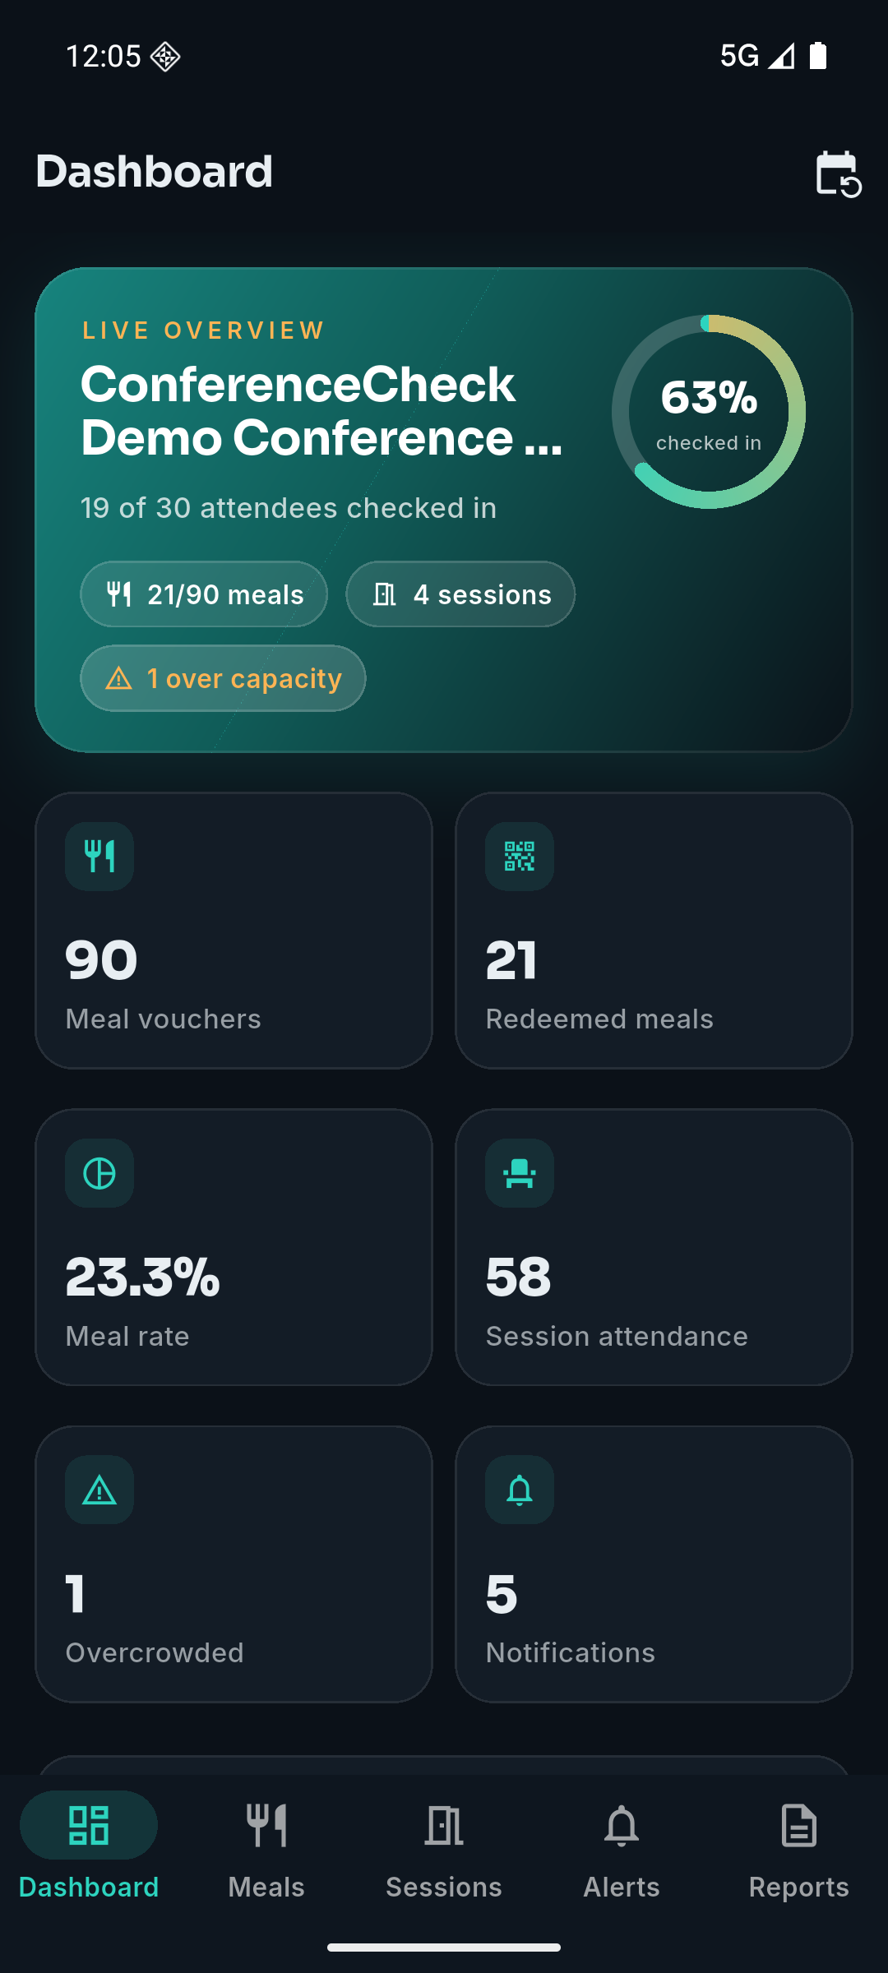
Check-in progress as both a count and a percentage, 19 of 30 at 63%, with meal vouchers issued and redeemed, redemption rate, session attendance, the count of sessions over capacity and the count of notifications sent. This is the single-screen view Section 3.6 describes, following Few's principle that a dashboard prioritises the small number of measures that drive action [7].
Figure 3. Trends and per-category redemption (Objectives 1 and 2).
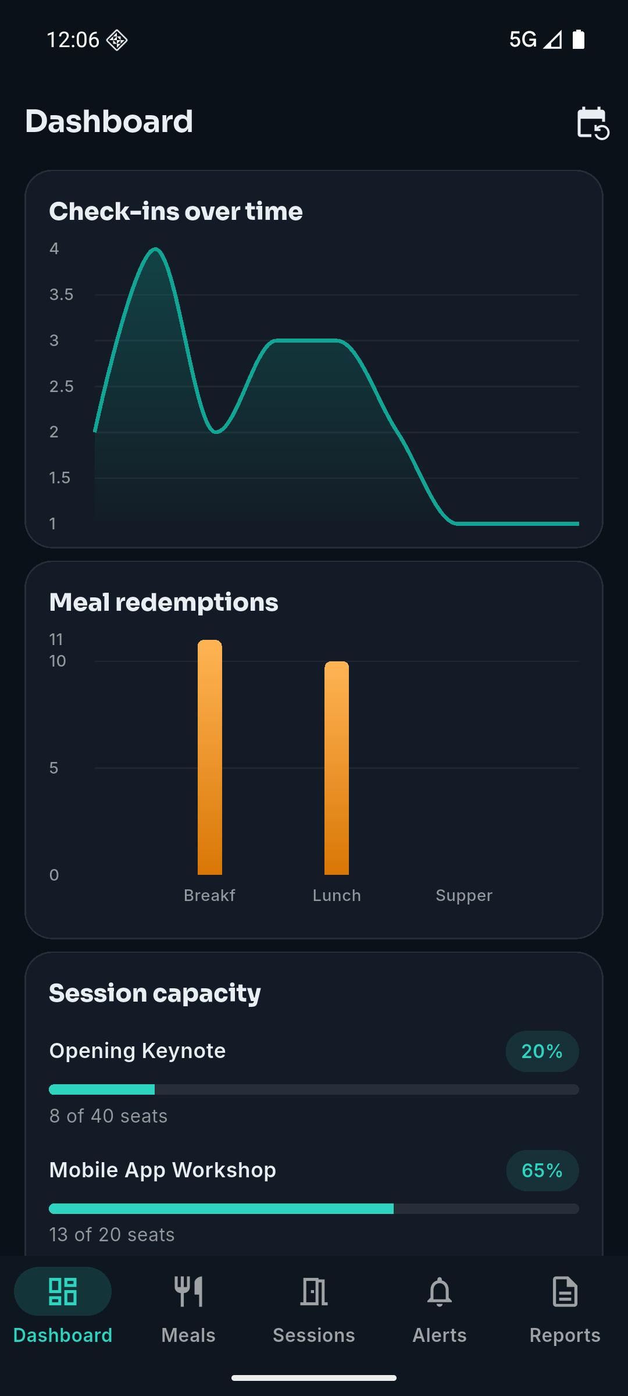
Check-ins over time is the trend view required by Objective 1. Meal redemptions are broken down by category, Breakfast, Lunch and Supper, which is Objective 2's multiple-category requirement shown in the interface rather than only in the schema. Session capacity appears as occupancy against seats for each session, 20% and 65% in this state, which is the reading Objective 3's capacity management is built on.
Figure 4. Automatic capacity alerts on a device (Objectives 3 and 4).
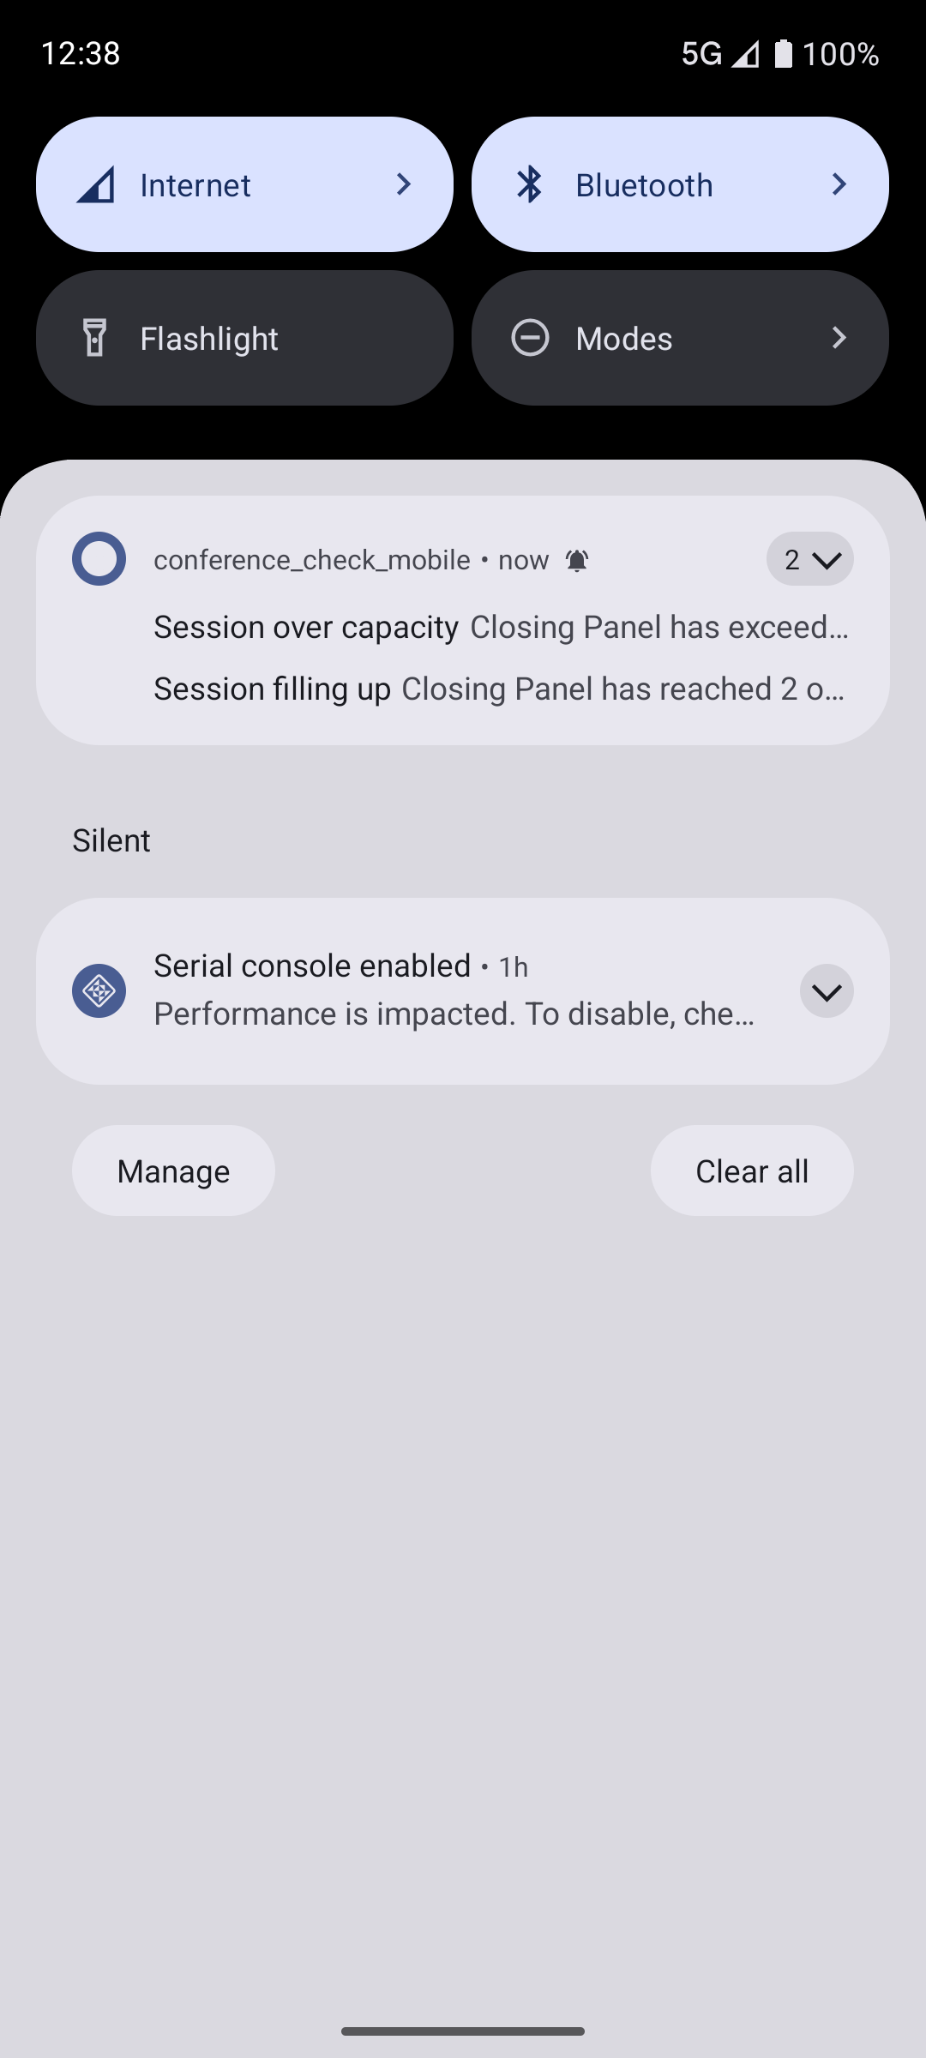
Both threshold transitions arriving as real push notifications on an Android device: the warning fraction, "Session filling up", and "Session over capacity". This is the evidence that the alerting in Section 3.4 reaches an organiser rather than only changing a value on a dashboard, and it exercises the same Firebase path as Objective 4.
Figure 5. Organiser broadcast delivered end to end (Objective 4).
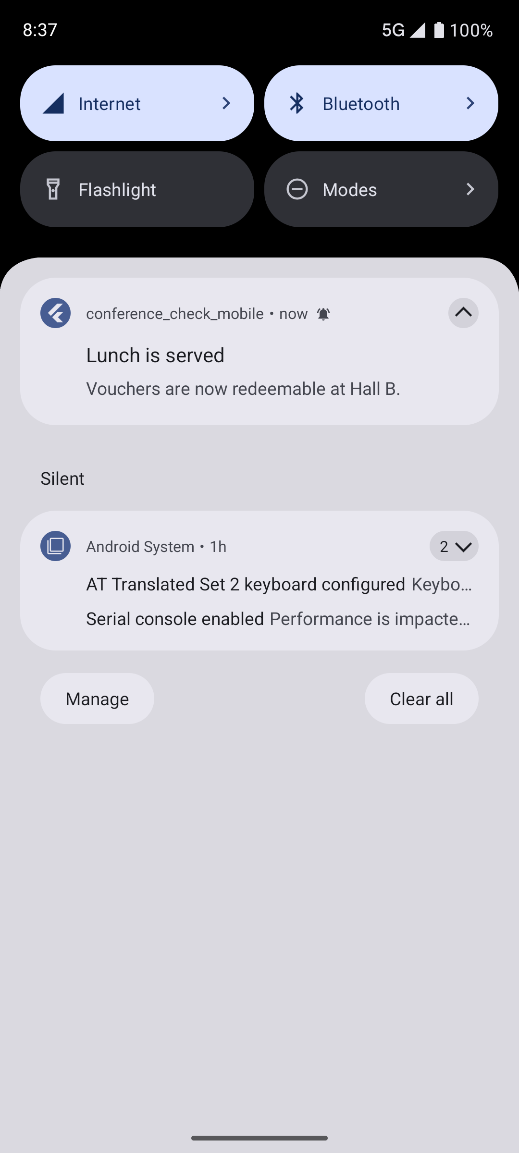
An organiser-composed message travelling from the backend through service-account authentication and Firebase Cloud Messaging v1 to a real device's notification shade. Section 6.7 reports the delivery measurements; this is the end of that path.
Figure 6. Attendee pass with a server-issued token (Objective 2).
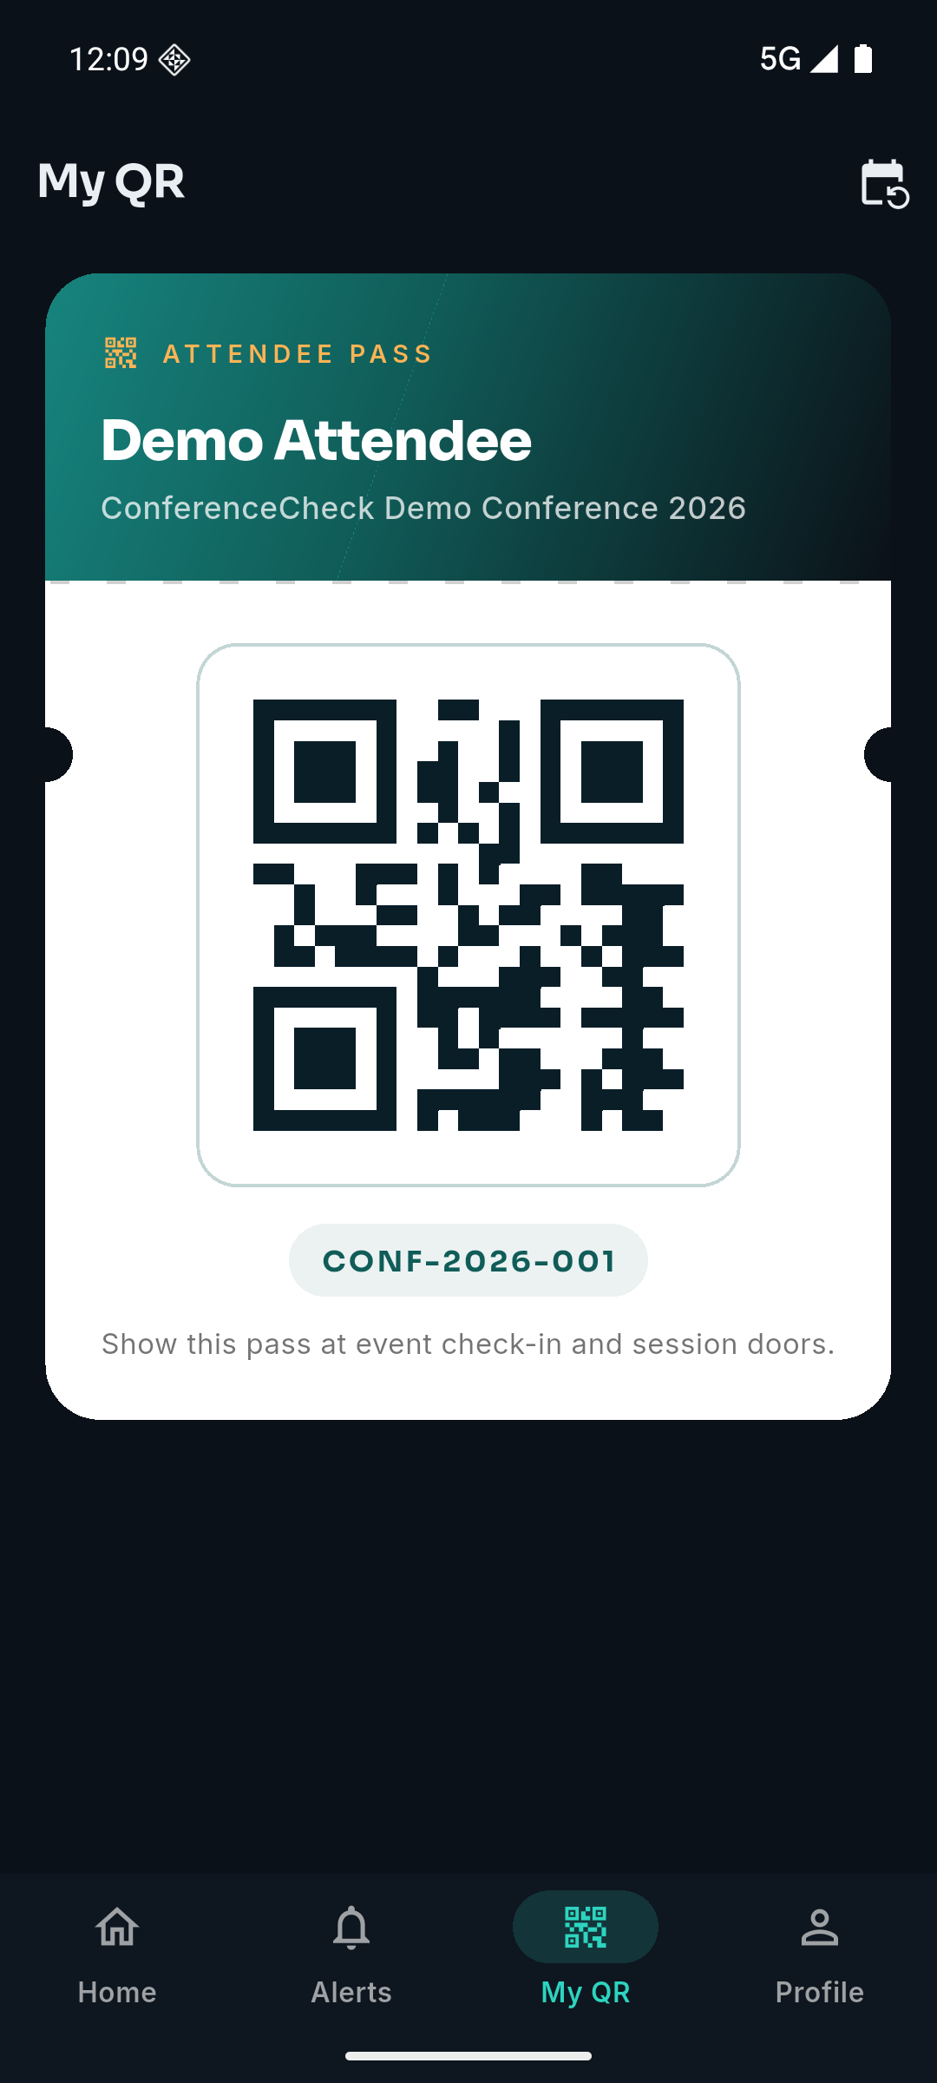
The attendee's own pass, carrying a QR token fetched from the authenticated endpoint rather than constructed on the device. This screen is the fix for the second defect in Appendix B, where the code had previously been fabricated client-side from a naming convention and would have broken for any attendee not present in the seed data.
Figure 7. Meal categories and the per-device redemption trail (Objective 2).
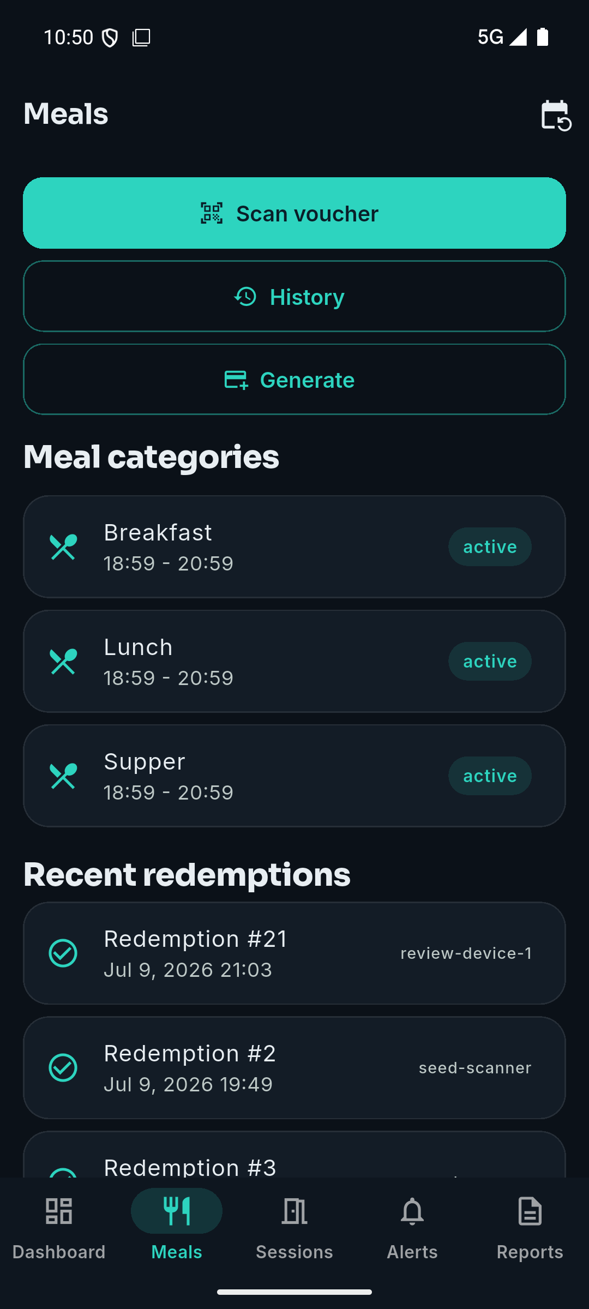
Three categories active at once, which is Objective 2's multiple-category requirement in the interface, and a redemption list in which each entry names the device that recorded it, which is the audit trail Section 3.3 describes.
Figure 8. Scanner accepting a voucher (Objective 2).
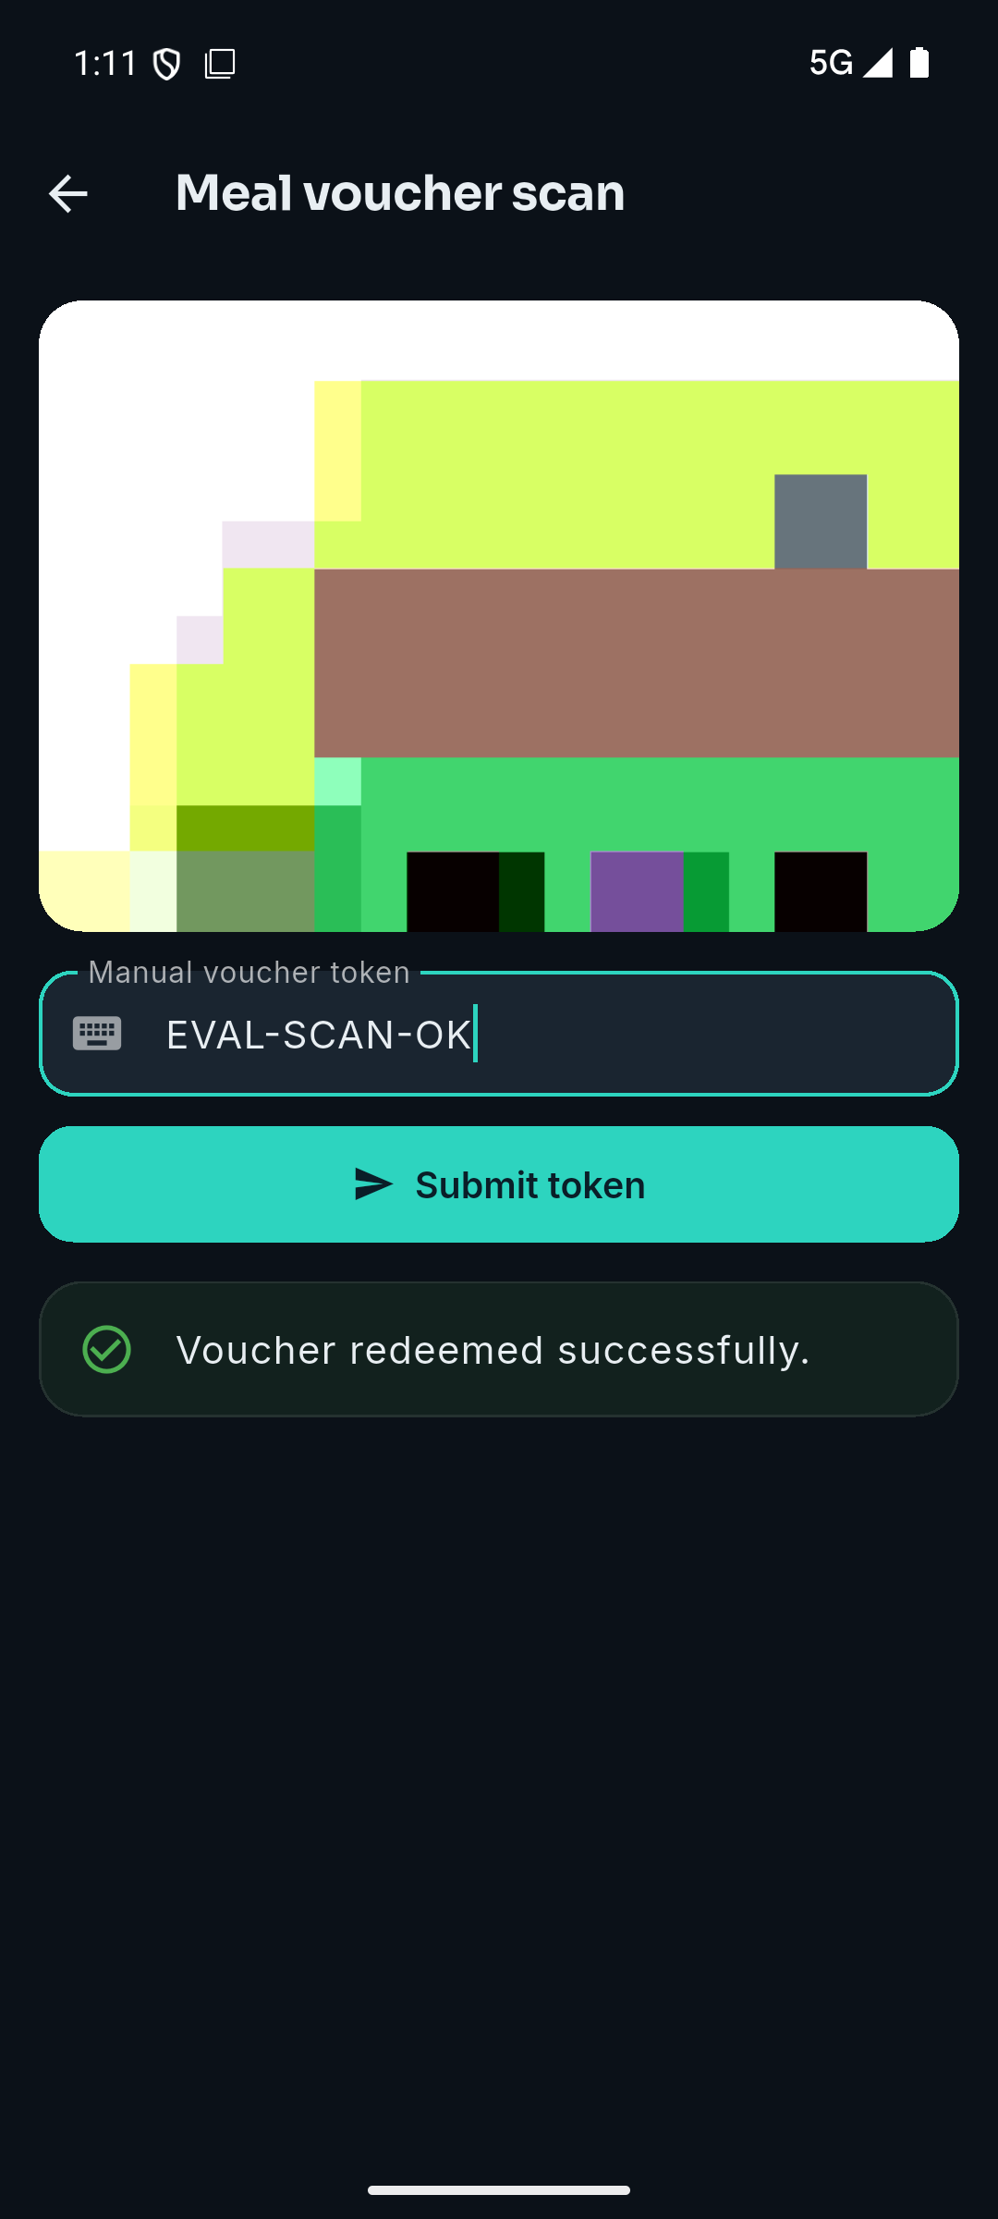
Figure 9. The same voucher refused on a second attempt (Objective 2).
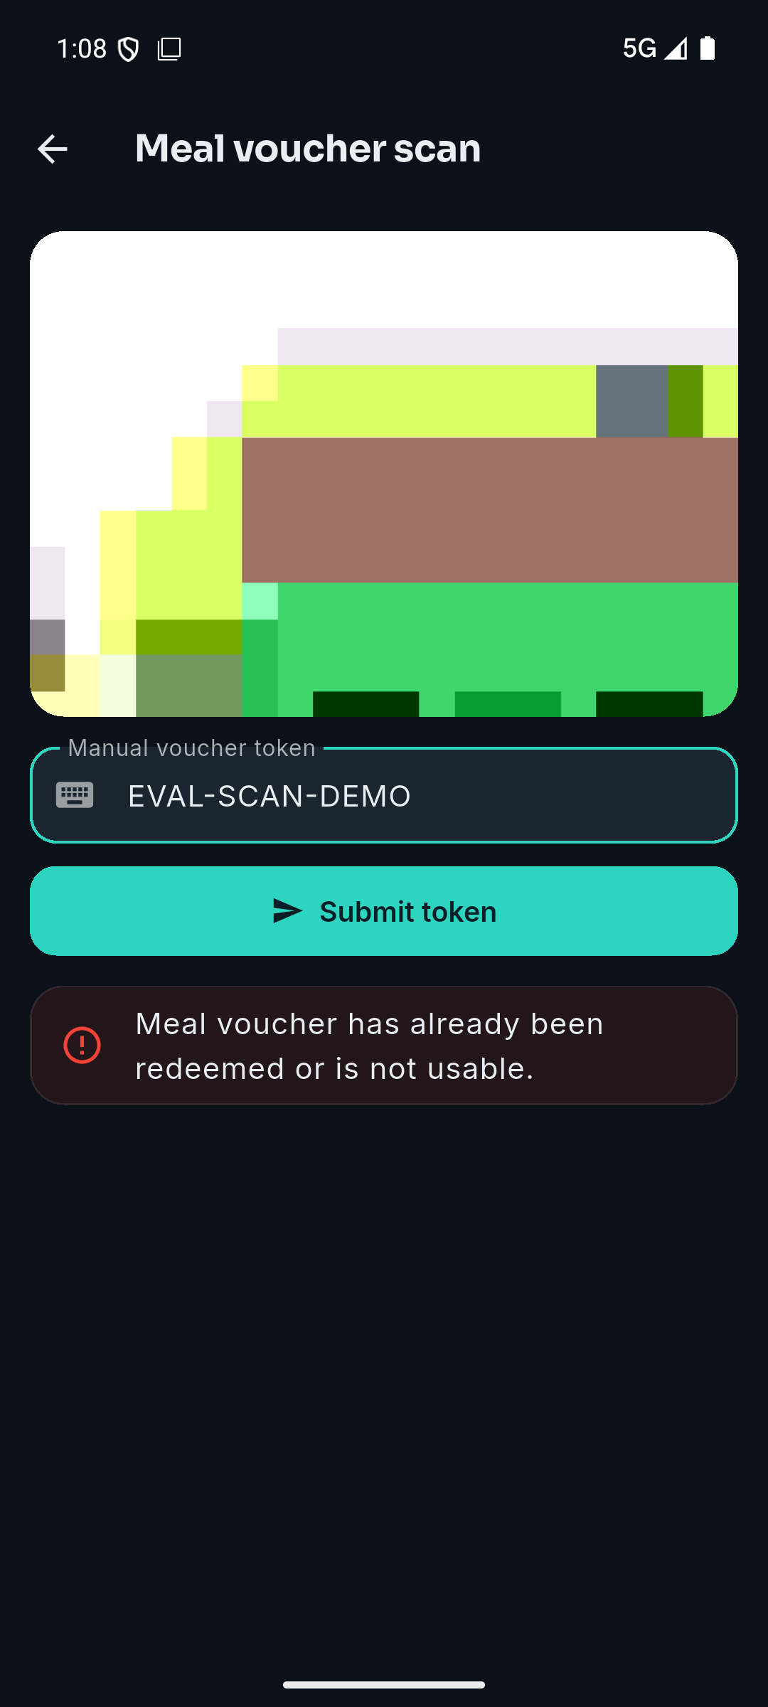
Figures 8 and 9 are the anti-fraud guarantee at the point of service: the same token accepted once and refused on its second presentation. The measurements in Section 6.2 count this behaviour 120 times; these are what a scanner operator sees when it happens.
Figure 10. Report exports available to an organiser (Objective 5).
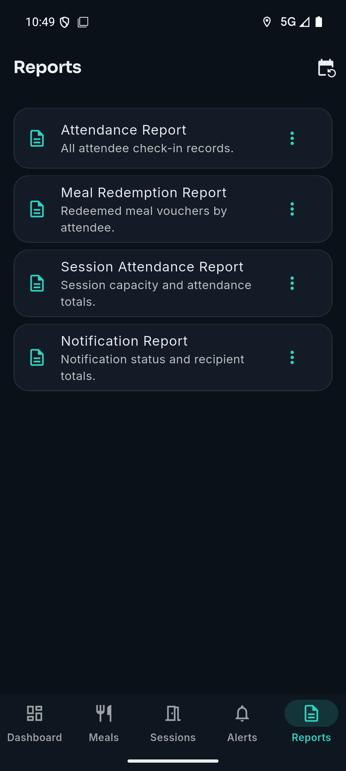
The four CSV exports whose row counts are checked against database ground truth in Section 6.6.

E.1 What these figures do and do not show
Figures 8 and 9 were produced through the scanner's manual token entry rather than by decoding a printed code with the camera. The submission path is identical from the server's point of view, and it is the server that enforces single use, so the guarantee shown is the real one. What is not shown is the decode step itself: these figures are evidence that a presented token is accepted once and refused thereafter, not evidence that the camera reads a QR symbol correctly. Decoding is exercised by the Flutter client's own tests and by the attendee pass in Figure 6, which renders a real scannable token, but no figure in this report shows a camera decoding one.
The figures were captured on an Android emulator against the seeded demo and evaluation events, so the device diversity limitation in Section 8 applies to them as it does to the push-delivery timing.

Appendix F. Reference verification record
Every reference was checked against its own source on 22-23 September 2026 for authors, title, venue, year and pages, and, where the report relies on a source for a specific claim, for whether the source actually makes that claim. The check is recorded here because a reference list that has never been opened is not evidence of anything, and because one entry did not survive it.
Table F1. Verification of every reference, including the one withdrawn.
Ref | Bibliographic check | Claim check
[1] ISO/IEC 18004:2015 | Correct; title and year match the ISO record exactly | Cited for the symbology and its error-correction levels, which the standard specifies. A 2024 edition now exists; the 2015 edition is the one consulted
[2] Tiwari, ICIT 2016, pp. 39-44 | Correct; venue, year and pages match | Cited for QR capacity, omnidirectional scanning and decode robustness, all of which the paper covers
[3] Masalha and Hirzallah, IJACSA 5(3), pp. 75-79, 2014 | Correct; volume, issue, pages and year all match | Overstated, and corrected. The report previously said this work "evaluated" a system and "found substantial reductions" in processing time and recording error, and that it "measured processing time and recording accuracy... against a real manual register". The full text contains no experiment, no measurement and no manual-register comparison; it is a design proposal with an analysis section. Four passages were rewritten. What the source does support, and is still cited for, is the photographed-code weakness, which its analysis states directly
[4] Mohammed and Zidan, IJEECS 31(3), pp. 1716-1723, 2023 | Verified in the Crossref record for DOI 10.11591/ijeecs.v31.i3.pp1716-1723; authors, venue, volume, issue and year all match | Cited for regenerating the code twice a second so a photographed code is stale on re-presentation. The abstract states the method and reports improved accuracy and a positive reception from surveys and record analysis; it gives no figures, and none are attributed to it here
[5] Nwabuwe, Sanghera, Alade and Olajide, IJACSA 14(4), pp. 938-945, 2023 | Verified in Crossref and against the article PDF, whose running head and page numbers confirm the volume, issue and range | Cited for geofencing by encoding the venue polygon in the code, and for IMEI verification against proxy registration. Both appear in the abstract, and the full text states plainly that a generated code "can be easily shared amongst colleagues". Its evaluation is reported qualitatively, so no measured result is attributed to it
[6] Alsuhibany, Sensors 25(13), art. 3855, 2025 | Verified in the Crossref record for DOI 10.3390/s25133855 | Cited for watermarking a QR symbol so tampering can be detected, evaluated on 5,000 samples. The abstract reports high accuracy without a single headline figure, and none is invented here
[7] Few, O'Reilly Media, 2006 | Correct; first edition, publisher and year match | Cited for the single-screen dashboard principle, which the book argues
[8] Nielsen, Morgan Kaufmann, 1993 | Correct as a real 1993 edition. The original hardcover was Academic Press; Morgan Kaufmann published the 1993 paperback, which is the form cited | Cited for the response-time thresholds, which the book sets out
[9] Firebase Cloud Messaging documentation, landing page | Live and official | Narrowed. The page describes FCM as a solution that "lets you reliably send messages"; it does not mention latency or cost. Section 1 had cited it for "reliable, low-latency delivery... at no marginal cost", so the latency and cost claims were dropped. What remains is what the page states
[10] Google, "FCM architectural overview" | Live and official | Added so that the registration-token claim cites the page that makes it: "An instance of a client app registers to receive messages, obtaining a registration token that uniquely identifies the app instance"
[11] Google, "Understanding message delivery" | Live and official | Added so that the best-effort claim cites the page that makes it. The page states that a message ID returned to the sender means the message "was accepted for delivery", not delivered, that a message for an offline device is stored until the device reconnects, and that delivery may be delayed
[12] Fielding, PhD dissertation, UC Irvine, 2000 | Correct; institution and year match | Cited for the REST architectural style, which the dissertation introduces
[13] RFC 6750, Jones and Hardt, Oct. 2012 | Correct; authors, number, title and date match the RFC Editor record | Cited for bearer-token usage, which is the RFC's subject
[14] Laravel Sanctum documentation | Live and official | Cited for token authentication, which it documents
[15] OWASP MASVS v2.0, 2023 | Correct; v2.0.0 was released in April 2023 | Cited for mobile hardening guidance, which it provides
[16] Helland, CACM 55(5), pp. 56-65, 2012 | Correct; volume, issue, pages and year all match | Cited for idempotence under retry, which is the article's argument
[17] Krasner and Pope, JOOP 1(3), pp. 26-49, 1988 | Correct; volume, issue, pages and year all match | Cited for the Model-View-Controller separation, which the paper describes
[18] Data Protection Act No. 3 of 2021, Zambia | Correct; the Act exists under that number and year | Cited for data-minimisation and consent obligations, which it imposes
[19] Flutter documentation | Live and official | Cited for cross-platform delivery from one codebase
[20] Berenson, Bernstein, Gray, Melton, O'Neil and O'Neil, SIGMOD 1995, pp. 1-10 | Checked against the paper's own text (the authors' PDF) and the DBLP record for DOI 10.1145/223784.223785 | Cited for the lost update anomaly (its P4): a transaction reads an item, another updates it, and the first then writes on the basis of its read. No other claim is attributed to it
[21] PostgreSQL 18 documentation, Section 13.3 "Explicit locking" | Live and official; checked against Section 13.3.2, "Row-Level Locks" | Cited for FOR UPDATE blocking other transactions that lock, update or delete the row until the locking transaction ends
[22] PostgreSQL 18 documentation, Section 63.5 "Index uniqueness checks" | Live and official | Cited for a would-be inserter of a duplicate key waiting for the uncommitted inserting transaction, and failing with a uniqueness violation if that transaction commits
Schwaber and Sutherland, The Scrum Guide, 2020 | The document exists as cited | Withdrawn. Not cited anywhere in this report, and Scrum is not discussed in it. Removed from the list rather than left as an entry nothing refers to
Both items this check first recorded as outstanding have since been closed. The Firebase citation, which pointed at the documentation root rather than at the pages carrying the claims, was split into [9], [10] and [11]. The recent event-technology literature Section 2 lacked has been added as [4], [5] and [6]: each was located through Crossref, verified against its own record, and read before being cited, and what each is cited for is recorded above alongside what it does not support. Three sources on concurrency control, [20], [21] and [22], were added after the supervisor noted that the literature the central claim rests on was missing; each was checked against its own text before being cited.

